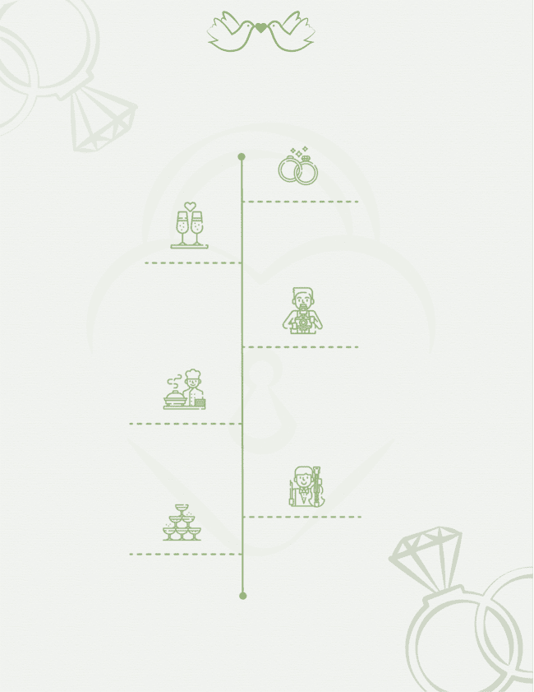

Andrew & Selena

Lorem ipsum dolor sit amet, consectetur adipiscing elit,

**Party**

Lorem ipsum dolor sit amet, consectetur adipiscing elit,

**Toast**

Lorem ipsum dolor sit amet, consectetur adipiscing elit,

**Toast**

**01:00 AM**

**09:00 PM**

**Music**

Lorem ipsum dolor sit amet, consectetur adipiscing elit,

**Dinner**

Lorem ipsum dolor sit amet, consectetur adipiscing elit,

**Wedding**

Lorem ipsum dolor sit amet, consectetur adipiscing elit,

**07:00 PM**

**12:00 AM**

**07:30 PM**

**06:00 PM**