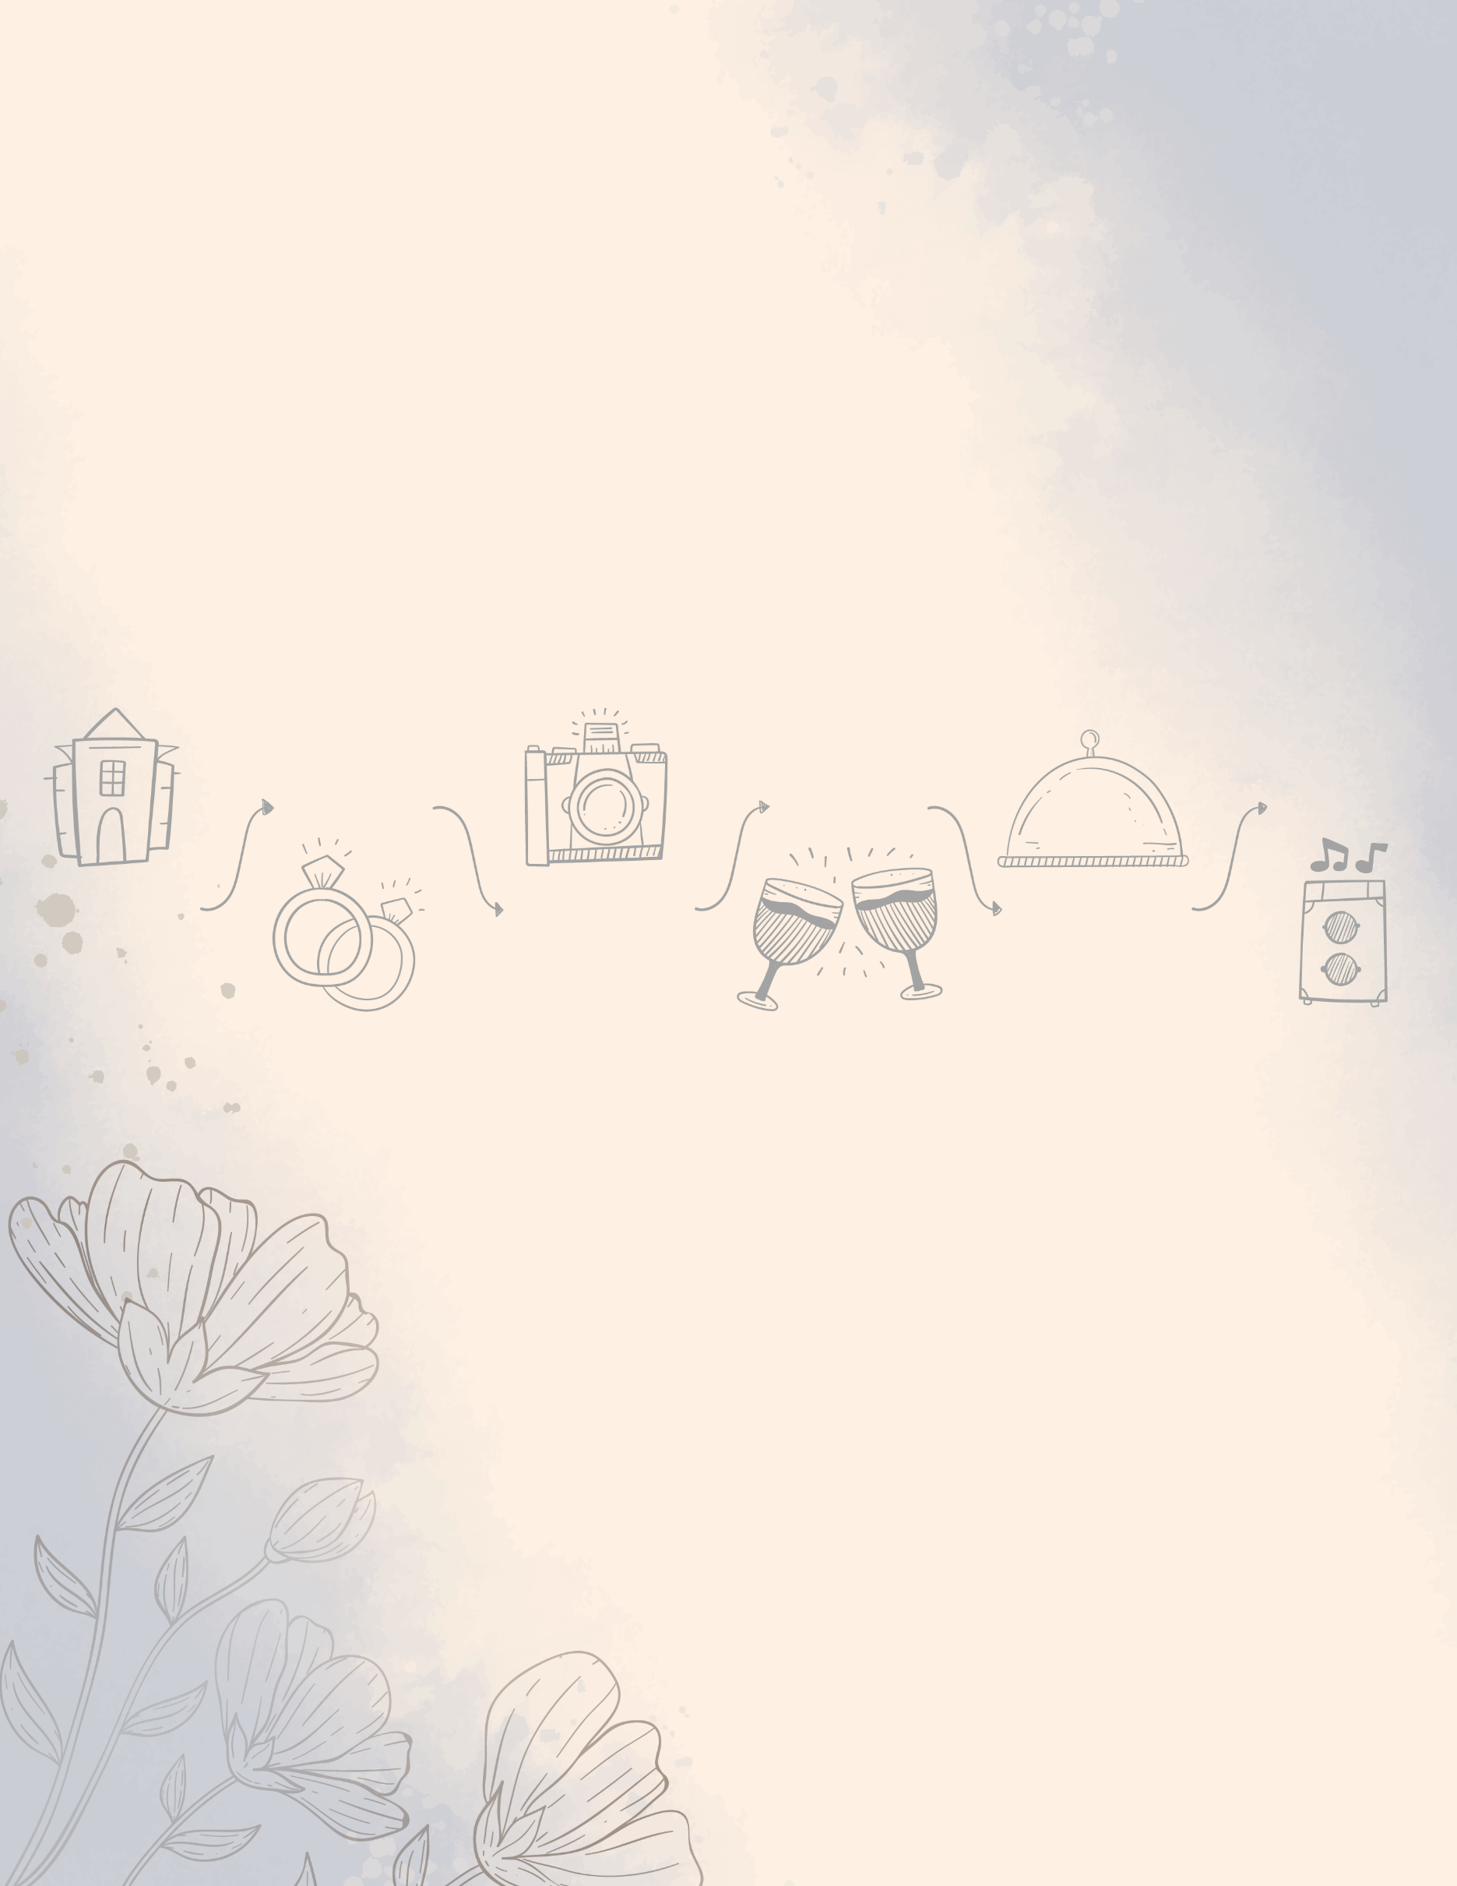

05-09-23

Save the Date

Wedding Program

Andrew & Selena

**06:00 PM**

**Party**

Lorem ipsum dolor sit amet, consectetur adipiscing elit,

Lorem ipsum dolor sit amet, consectetur adipiscing elit,

**Dinner**

**05:30 PM**

Lorem ipsum dolor sit amet, consectetur adipiscing elit,

**Toast**

**05:00 PM**

**Photo Shoot**

Lorem ipsum dolor sit amet, consectetur adipiscing elit,

**04:30 PM**

**Ceremony**

**Reception**

**03:00 PM**

Lorem ipsum dolor sit amet, consectetur adipiscing elit,

**04:00 PM**

Lorem ipsum dolor sit amet, consectetur adipiscing elit,

The

**BIG**

Day