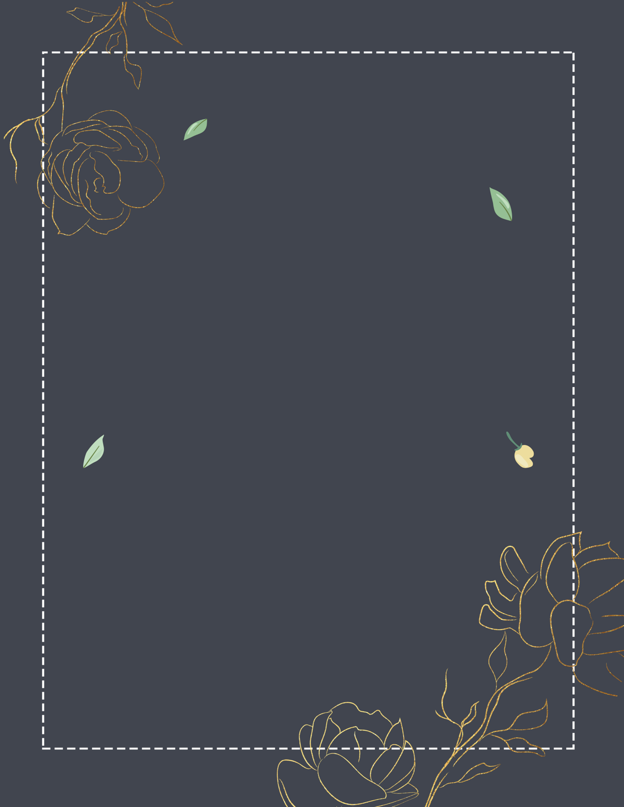

7:00 PM

Wedding Ceremony

08:00 PM

Photos Session

09:00 PM

Cocktails

10:00 PM

First Dancing

11:00 PM

Enjoying the Food

12:00 PM

Bouquet Toss

Wedding

PROGRAM