2017
Annual Security Report

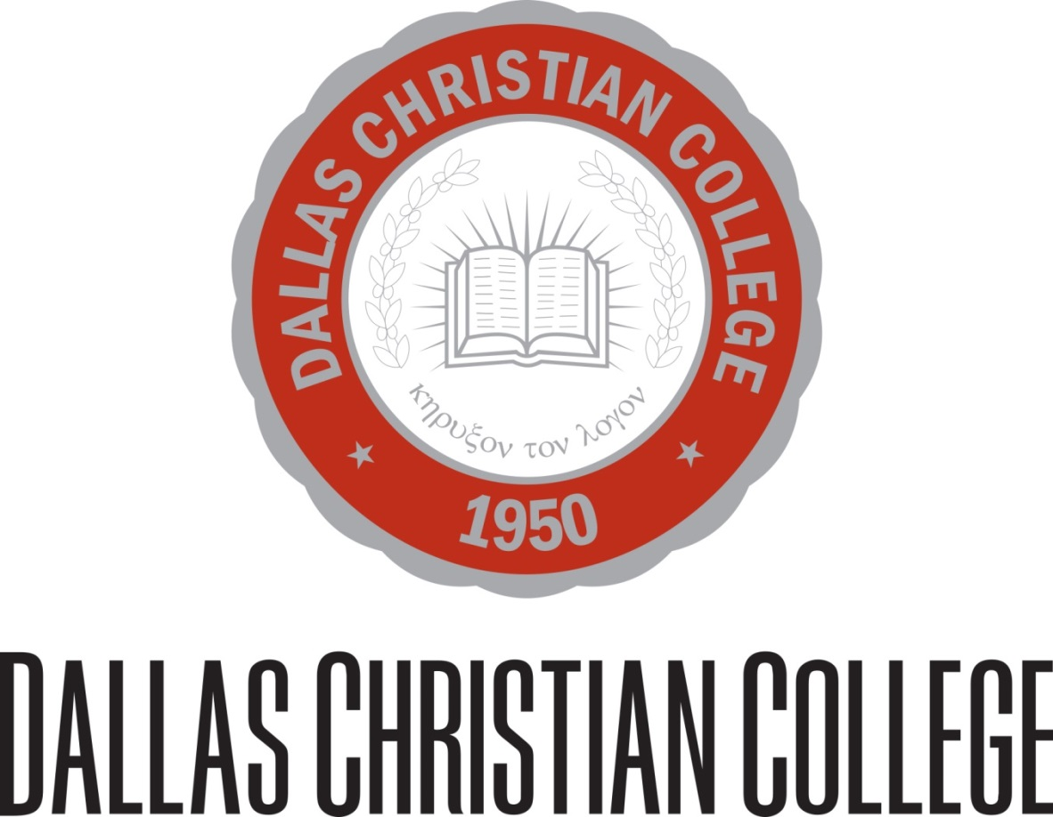

The 2017 Dallas Christian College Annual Security Report (ASR) has been provided to the DCC community in compliance with federal regulations and is designed to communicate safety and crime data, policies and procedures in order to maintain a safe and comfortable campus. Every member of the DCC community has a role in creating a safe environment. This report will describe the responsibility that we all share in that mutual cause.
In the following report, this ASR will convey the college’s policies and expectations for student and employee conduct. It will describe the procedure for reporting crimes and infractions of the student or employee code of conduct. This report provides historical crime data for 2014, 2015 and 2016, and it offers definitions often used by the DCC Security Office in preventing and responding to code of conduct infractions. In addition to security concerns, this ASR relays investigation, disciplinary and resolution procedures employed by the college. The report outlines the rights and options available to our students and employees relative to the code of conduct as well as how the college will communicate those rights and guide students/employees through the processes involved.
The Annual Security Report outlines security procedures for campus wide security events such as fire, inclement weather, power outage, chemical spills, etc. This report also contains historical data regarding such events as well as response drills conducted in 2016.
Lastly, this report offers assistance resource information for both institutional resources as well as outside agencies. These resources are in place to assist the student or employee in matters of legal counsel, reporting and prosecution, protection, and mental, emotional and spiritual wellness.
Dallas Christian College is proud to offer a safe environment for students and employees where we may grow together in the knowledge of our God. Where the code of conduct has been violated, our priorities are the protection of individuals and our community as well as the correction and restoration of the offender whenever possible. Questions regarding this Annual Security Report or any of the college’s security policies or procedures may be directed to the Security Office at titleIX@dallas.edu or 972-241-3371, ext. 161.

Reporting Crimes
Campus security is everyone's responsibility, and it is necessary to maintain sound and sensible precautions. It is therefore important for members of the college community to report any and all questionable incidents. Crimes that occur on campus are to be reported within 24 hours to the Vice President for Student Development whose office is located in the Administration building. Persons who may assist in reporting criminal actions include members of the Residence Hall Staff or the Student Development Office. Victims or witnesses of criminal activities are directed to complete an Incident Report that details the facts surrounding the crime. Report forms are available from the offices named above. In cases involving violation of local, state, or federal laws, the Farmers Branch City Police are notified for appropriate follow up. The College cooperates fully with any investigations conducted by proper authorities. In the event of a crime that poses a threat to the campus community, notice may be made through the college's emergency notification system, through email and through regular announcement venues in high traffic areas of the campus.
Residence Halls
During New Student Orientation, crime prevention is addressed through a review of precautions necessary to provide for one's personal safety and well-being. Literature is distributed and posters displayed on campus which recommend ways to protect one's self and his or her belongings.
Residence hall programs also cover the topic of crime prevention as it relates to campus housing and safety procedures.
The residence halls and other campus buildings have an announced closing hour during the year. Any exceptions to these times must be approved by the Administration in advance of a scheduled event. Occupants of the residence halls are issued keys which access the main lobby door and the individual room.
For additional assistance the resident must contact Housing Staff to be admitted to the hall. All residents must be prepared to provide proper identification upon request of a college official.

The Clery Act reportable area for Dallas Christian College:
The area from Villa Creek Drive to the South to the area bordered by the baseball diamond and
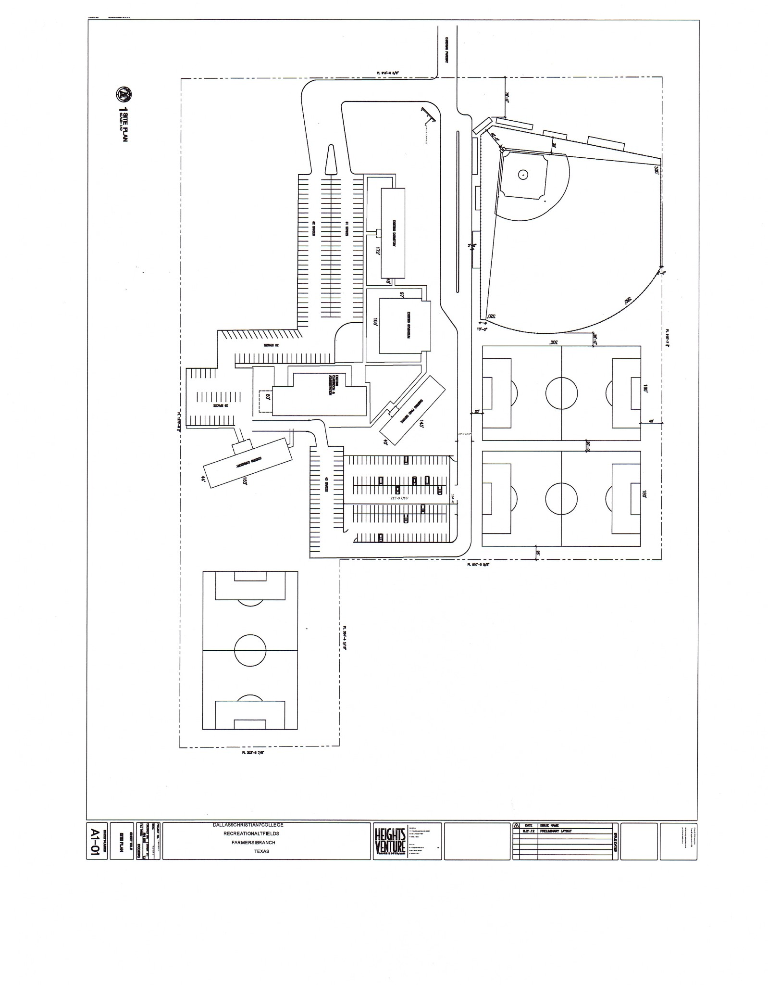
soccer fields to the north. From the entrance to the west entrance of the College to the area which is adjacent to Koruth Alley to the east.
Crime Statistics - The Student Right to Know information is prepared annually by Dallas Christian College, to comply with the Jeanne Clery Disclosure of Campus Security Policy and Crime Statistics Act. In keeping with federal legislation, "The Crime Awareness and Security Act of 1990" "Clery Legislation, (Title II, Public Law 101-542," as amended), the following information related to these incidents is to be published annually. This report also contains specific crime statistics in compliance with the Campus Sexual Violence Eliminated Act (SaVE Act) which was passed in March 2013 as part of the Violence Against Women Reauthorization Act (VAWA).
This Annual Security Report (ASR) includes statistics for the most recent three-year period concerning reported crimes that occurred on college grounds and surrounding areas, owned and operated by the college. Crime statistics include those offenses reported to other law enforcement agencies for the areas immediately adjacent to and accessible from the campus or non-campus locations. Each year, notifications are emailed to all enrolled students, faculty, and staff that provide the website URL to access this report on the internet. Copies of the report may be obtained by current or prospective students, faculty and staff, from the Chief Security Officer, Eric Hinton in the Student Development Office at Dallas Christian College, 2700 Christian Parkway, Dallas, Texas 75234.
Dallas Christian College attests that all materials have been distributed in accordance with the Clery Act above, understand all of the Clery Act requirements and obligations, and taken all necessary steps to ensure no violations recur.
Newly required Sexual Crime statistics and Hate Crime statistics for the 2014 calendar year are reported later in this report.
Physical Address | Security Officer | Fire Safety Officer
2700 CHRISTIAN PKWY  DALLAS, TX 75234-7299 | Name: Mark Worley  Title: Dir. of Campus Security  2700 CHRISTIAN PKWY  DALLAS, TX 75234-7299  Phone: 972-241-3371(152) | Name: Jason Knowles  Title: Director of Facilities  2700 Christian Parkway  Dallas, TX 75234  Phone: 972-241-3371(115)
Criminal Offenses - On campus
 | Total occurrences On campus
Criminal offense | 2014 | 2015 | 2016
a. Murder/Non-negligent manslaughter | 0 | 0 | 0
b. Negligent manslaughter | 0 | 0 | 0
c. Sex offenses - Forcible | 0 | 0 | 0
d. Sex offenses - Non-forcible | 0 | 0 | 0
e. Robbery | 0 | 0 | 0
f. Aggravated assault | 0 | 0 | 0
g. Burglary | 0 | 0 | 1
h. Motor vehicle theft | 0 | 0 | 0
i. Arson | 0 | 0 | 0

Criminal Offenses - On-campus Student Housing Facilities
 | Total occurrences in On-Campus Student Housing Facilities
Criminal offense | 2014 | 2015 | 2016
a. Murder/Non-negligent manslaughter | 0 | 0 | 0 0
b. Negligent manslaughter | 0 | 0 | 0 0
c. Sex offenses - Forcible | 0 | 0 | 0 0
d. Sex offenses - Non-forcible | 0 | 0 | 0 0
e. Robbery | 0 | 0 | 0 0
f. Aggravated assault | 0 | 0 | 0 0
g. Burglary | 2 | 0 | 0 0
h. Motor vehicle theft | 0 | 0 | 0 0
i. Arson | 0 | 0 | 0 0

Criminal Offenses - Public Property
 | Total occurrences on Public Property
Criminal offense | 2014 | 2015 | 2016
a. Murder/Non-negligent manslaughter | 0 | 0 | 0 0
b. Negligent manslaughter | 0 | 0 | 0 0
c. Sex offenses - Forcible | 0 | 0 | 0 0
d. Sex offenses - Non-forcible | 0 | 0 | 0 0
e. Robbery | 0 | 0 | 0 0
f. Aggravated assault | 0 | 0 | 0 0
g. Burglary | 0 | 0 | 0 0
h. Motor vehicle theft | 0 | 0 | 0 0
i. Arson | 0 | 0 | 0 0

Sexual Misconduct Policy and Procedures
The DCC Student Handbook and Employee Handbook prohibit various forms of sexual misconduct in keeping with the character and identity of the college as explicitly Christian in nature. Included in the code of conduct regarding sexual misconduct is a strict prohibition of sexual harassment, sexual assault, dating violence, domestic violence and stalking. DCC’s Sexual Misconduct Policy and Procedures are designed to eliminate such misconduct from the college campus and to protect the institution’s students and employees.
- Definitions
This section will define the terms often used at Dallas Christian College in our policies and procedures:
Consent is a clear, mutual, voluntary and positive agreement between participants. Consent must be explicitly expressed. Consent should never be assumed because the other party did not express objection. Unless consent from all participants is clear, a lack of consent should be assumed. A lack of consent can be expressed through body language, attitude or gestures. A prior sexual relationship does not constitute current consent. Consent must be offered at each stage of sexual activity and should not be assumed based on previous stages of sexual interaction.
Consent requires that a person:
- Is unimpaired by any substance, alcohol or drugs and is of a state of mind to make informed decisions.
- Is of the legal age of consent (17 years of age in Texas).
- Is fully conscious and awake.
- Is of sound body and mind without any known mental disorder.
Domestic Violence is defined by Texas Penal Code Sec. 71.004 as 1) an act by a member of a family or household against another member of the family or household that is intended to result in physical harm, bodily injury, assault or that is a threat that reasonably places the member in fear of imminent physical harm, bodily injury, assault or sexual assault, but does not include defensive measures to protect oneself; 2) abuse… by a member of a family or household toward a child of the family or household; or 3) dating violence.
Dating Violence is defined by Texas Penal Code Sec. 71.0021 as an act by an individual that is against another individual with whom that person has or has had a dating relationship and that is intended to result in physical harm, bodily injury, assault, or sexual assault or that is a threat that reasonably places the individual in fear of imminent physical harm, bodily injury, assault, or sexual assault, but does not include measures to protect oneself. A dating relationship is determined with consideration to the length of the relationship, the nature of relationship and the frequency of interaction between the individuals in question.
Sexual Assault is generally defined by Texas Penal Code 22.011 as any non-consensual sexual contact by another person involving penetration, however slight, of the vagina or anus with any body part or object or of oral penetration of another person by a sex organ without explicit consent. Sexual assault includes rape, fondling, incest and statutory rape.
Stalking is described by Texas Penal Code 42.072 as when a person on more than one occasion and pursuant to the same scheme or course of conduct directed at a specific person knowingly engages in conduct that: 1) the stalker knows/reasonably believes the victim will view as threatening, 2) causes fear, and 3) would cause a reasonable person to fear.
- Sexual Assault Education and Prevention Programs
Dallas Christian College implements sexual assault awareness and prevention programing for all new traditional students through the first-year experience course called DCC 101 as well as through informal yet consistent emphasis and ad hoc programing in residence hall meetings. New employees receive training upon hire from the DCC Human Resources department as well as instruction in employee meetings. The curriculum entitled One is Too many was presented on March 30, 2016 and September 13, 2016. New employees receive training upon hire from the DCC Human Resources department as well as instruction in employee meetings.
Sexual harassment/assault prevention training includes comprehensive instruction for the purpose of eliminating sexual assault and sexual harassment on DCC’s campus. Students and employees are informed of the college’s Sexual Misconduct Policy and Procedures and are informed regarding definitions of consent, sexual harassment, sexual assault, domestic violence, dating violence and stalking. Students and employees are informed of risk reduction practices to avoid being sexually victimized as well as options for bystander intervention if one witnesses sexual harassment/assault.
- Sexual Assault Response Procedures
Dallas Christian College employs response procedures designed to offer a discrete and effective reporting system, thorough investigation practices, and comprehensive assistance and guidance services for the victim as well as the accused. Individuals involved in a sexual assault case will be informed of their rights, investigative and disciplinary procedures and outcomes, support services such as preliminary legal assistance and counselling, and adjustments to prevent contact between the victim and the accused in classes and on-campus living accommodations to the fullest realistic extent.
In the event that a student experiences sexual harassment, sexual assault, domestic violence, dating violence or stalking, the victim is advised to report the incident immediately to one of the following persons on campus:
Name | Title | Phone | Email | Location
Mark Worley | Vice President of Student Development | 972-241-3371 ext. 152 | mworley@dallas.edu | President’s Suite on 1st floor of Admin. Bldg.
Tyese Little | Winslow Hall Residence Director | Number provided to residents | tlittle@dallas.edu | Winslow Hall RD Apartment
Gary Hardy | Newland Hall  Residence Director | Number provided to residents | ghardy@dallas.edu | Newland Hall RD Apartment
Lydia Meeks | Title IX Coordinator | 972-241-3371  ext. 161 | lmeeks@dallas.edu | President’s Suite on 1st floor of Admin. Bldg.

In the event that an employee experiences sexual harassment, sexual assault, domestic violence, dating violence or stalking, the victim is advised to report the incident immediately to one of the following persons on campus:
Name | Title | Phone | Email | Location
Departmental Supervisor
Andrea Short | Vice President of Finance (including HR) | 972-241-3371 ext. 166 | ashort@dallas.edu | Business Office on 1st floor of Admin. Bldg.
Mark Worley | Vice President of Student Development | 972-241-3371 ext. 152 | mworley@dallas.edu | President’s Suite on 1st floor of Admin. Bldg.
Lydia Meeks | Title IX Coordinator | 972-241-3371  ext. 161 | lmeeks@dallas.edu | President’s Suite on 1st floor of Admin. Bldg.

The victim is also strongly encouraged to immediately call 911 to report the assault to the Farmers Branch Police Department for criminal investigation or call them directly at 972-484-3620 or 3723 Valley View Ln., Dallas, TX 75244. The College will provide reasonable assistance to students who request such assistance in filing a report on or off campus. Medical treatment is advised at an area hospital in order to preserve evidence that may be needed in the investigation. The hospital nearest the DCC campus is Dallas Medical Center located at 7 Medical Pkwy, Dallas, TX 75234, 972-888-7000. Services may also be obtained through the Dallas Rape Crisis Center at 214-590-0430.
A victim of a sexual crime will be encouraged to preserve evidence of that crime. Such preservation includes not bathing, washing, douching or changing bedding following an incident of sexual assault. Victims should also preserve any applicable media such as pertaining pictures/videos, text messages, social networking pages, or any other evidence that would assist the college’s investigative efforts.
While DCC will strongly encourage and support the victim in reporting sexual crime to the appropriate law enforcement agency, this choice lies solely with the victim. The college cannot require a victim of sexual assault to participate in the criminal justice system or cooperate with law enforcement in order to be provided with a forensic medical exam, reimbursement for charges incurred on account of such an exam, or both.
The procedures listed below are intended to provide a prompt and thorough response to charges of sexual assault, domestic violence, dating violence and/or stalking. The college will maintain confidentiality and fairness to all parties to the fullest extent afforded within legal requirements. These procedures will also outline appropriate sanctions against violators of the college’s sexual assault policies.
In all cases, the college will make determinations based on the preponderance of evidence. This means that after gathering all of the evidence available for a given case, the college will make a determination as to the most likely course of events that transpired.
- First concern will be given to the complainant’s safety and wellbeing. The college will assist in guiding the complainant to medical care if needed. The college will assess the current, ongoing threat to the complainant as well as to others by the accused and will take necessary preventative measures to ensure that any immediate and near-future threat by the accused is neutralized. This could include action by law enforcement agencies as well as a “no trespassing” order authorized by the college against the accused.

- The complainant will be instructed as to how to contact local law enforcement and will provide that contact information upon the complainant’s request.

- The complainant will be instructed as to how to preserve evidence pertaining to the case.

- The college will provide the complainant with instructions as to how to apply for Protective Order.

- The complainant will be provided with on and off-campus mental health and counselling resources.

- The college will provide the complainant and the accused (if applicable) a copy of the institution’s Sexual Misconduct Policy and Procedures. The complainant and the accused will be informed regarding the time frame of the investigation and resolution.

- The college will consider necessary protection measures and/or accommodations to prevent contact between the complainant and the accused such as changes in housing accommodations, on-campus employment, class scheduling and locations, etc.

- The complainant and the accused will receive simultaneous written notice of the determination of the college following investigation. All parties involved will be informed of the charges and outcomes of the case.

- Dallas Christian College prohibits retaliation by its officers, employees or agents against a person who exercises his or her rights or responsibilities under any provision of the Campus SaVE Act.
Disciplinary measures that the college may observe at the completion of investigation vary based on the severity of the infraction and may include a written warning, disciplinary probation, or disciplinary suspension and/or expulsion from the institution.
- Rights and Options for Victims
Dallas Christian College is committed to assisting victims following incidents of domestic violence, dating violence, stalking, and sexual assault and harassment regardless of whether or not the victim(s) choose to file a criminal complaint. The college will provide a written explanation of his/her rights and options which include protective measures against the accused. Those rights are specified below.
- While the college cannot file any restraining/protective order on behalf of the complainant, the college will commit to enforce to our greatest extent possible any such order that the complainant obtains. The victim must personally file for such orders through the appropriate law enforcement agency. The complainant should submit the restraining/protective order to the Vice President of Student Development or the Dean of Students.
- The Student Development Office may devise a Safety Action Plan which will be designed to reduce risk of harm to the victim while on campus. The Safety Action Plan offers measures including but not limited to: modified classroom location and environment such as work from home, housing change, meal arrangements, and escorts.
- Accommodations of any protective order and/or the Safety Action Plan will remain confidential to the fullest extent possible.
- The victim has the right to confidentiality as much as is possible. Personal information identifying the individual or the circumstances of the case is shared only with college personnel on a need to know basis. The college does not publish the names of victims.

- Investigative and Disciplinary Procedures
Cases of sexual misconduct including sexual harassment, sexual assault, domestic violence, dating violence and stalking involving students will be presided over by the Ethical Conduct Committee (ECC) as described in the Dallas Christian College Student Handbook, section 14.8. Both the complainant and the accused will be offered prompt, fair and impartial treatment by the ECC throughout the investigation and resolution process. Members of the ECC receive annual training to respond to matters of code of conduct violations including the sex crimes listed above. ECC members are trained to conduct a hearing process that protects victim safety and promotes accountability.
The complainant and the accused will be informed prior to their meeting with the ECC of their right to be accompanied to that and all related meetings by an advisor, representative or counsel of their choosing.
The complainant and the accused will be informed during the ECC hearing of their right to appeal to the President of the college the resolution determined by the committee.
At the conclusion of the ECC investigation and deliberation, the complainant and the accused will receive simultaneous written notice of the following:
- The determination of the Ethical Conduct Committee based on the preponderance of evidence.
- The college’s appeal process as defined by section 14.9 of the DCC Student Handbook (and included below).
- Any changes or addendums to the determination before the ECC’s resolution is made final.
- When the results of the resolution are final.
For reference to the ECC procedure, the excerpt from the DCC Student Handbook is provided below:
14.8 Hearing Process 1. The student being called into a hearing of the Ethical Conduct Committee for unresolved matters will be notified of the time and location of the hearing not less than one day before the scheduled time. The student may choose to waive this notification in lieu of a quick resolve. 2. The student will be notified as to the charges against him or her and of the right to gather evidence and/or witnesses to contest the charge. 3. During the hearing, the committee and/or witnesses will present the evidence for the charge. 4. The student will then present rebuttal evidence and/or witnesses. The committee and the student will have the opportunity to cross-examine witnesses. 5. The student will be dismissed while the committee deliberates until a consensus for verdict and action is reached. 6. The student will be notified of the committee's decision. 7. A written digest of the hearing will be prepared for the student's file. It will include the charge, a list of witnesses who presented evidence, the decision as to guilt or innocence, and any penalties assessed. If a decision of innocence is reached, the student may ask the digest be removed from his or her file after one year. 8. If punitive or corrective measures are assessed, the Student Government will be notified as to the student involved and the measures levied. The charge will not be stated. 9. The college President will be given a copy of the student-file digest.
14.9 Appeal Process for Ethical Conduct Committee Decisions Students wishing to appeal decisions against them by the Ethical Conduct Committee must submit, in writing, a request for a second hearing of the committee within 30 days of the committee’s initial decision. The Ethical Conduct Committee shall reconvene as soon as possible to assess the student’s appeal and any additional arguments, evidence or witnesses presented. Should the student not be satisfied with the committee's decision after the appeal hearing, the student may make a final written appeal to the President. This final written appeal should be submitted to the President no later than 30 days following the appeal hearing with the Ethical Conduct Committee. The President’s decision is final.
14.10 Corrective Measures and Penalties Actions of the Ethical Conduct Committee include, but are not limited to:
- A written reprimand from the Dean of Students to the student and disciplinary probation; a copy of the reprimand is placed in the student's file
- Campus confinement for a specified period of time; students are confined to their rooms, except for classes, meals, chapel, work, and dorm devotions. They may be restricted from representing the school during the time of confinement.
- Monetary compensation for damage to college property and/or a person's property
- Assigned service to make restitution to a wronged individual(s)
- Assigned mandatory counseling from an approved counselor
- Disciplinary probation for one semester or a year with exclusion from representing the College in any official capacity, exclusion from leadership positions on campus, initiation of curfew, potential loss of scholarships, and/or exclusion from holding office in student organizations
- Reprimand, disciplinary probation, a zero for the course, failing the course, an “XF” for the course, suspension from the College, and/or loss of credit in the course or courses where dishonest work or inappropriate behavior was done
- Temporary suspension with time and terms of re-admittance indicated; (Suspension includes the forfeiture of refunds otherwise available in ordinary withdrawal from classes)
- Indefinite suspension with time and terms of readmission not indicated; (appeal for re-admittance must go through the committee);
- Receiving an “XF” as a Developing Christian Influence grade; which will be reflected on the student’s permanent record
- Loss by the student of any DCC scholarships and/or grants
- Any of the above may be noted on the student's transcript and may be removed at the discretion of the committee

Cases of sexual misconduct including sexual harassment, sexual assault, domestic violence, dating violence and stalking involving employees of the college will be handled as described in the DCC Employee Handbook. The relevant section has been included below.
Section 3.02 - Sexual Harassment (DCC Employee Handbook)
In all situations not covered specifically below, employees of Dallas Christian College are expected to act responsibly and for the welfare of the College community.
Employees are responsible for ensuring that their conduct does not include or imply harassment in any form. Harassment is defined as any annoying, persistent act or actions that single out another person, to that person's objection, because of, but not limited to, race, gender, religion, national origin, age, handicap, or innate personal characteristics. Dallas Christian College recognizes the Equal Opportunity Commission's identification of sexual harassment as:
- Verbal harassment consisting of sexual innuendos, suggestive comments, insults, humor and jokes on sex or gender traits, sexual propositions, and threats.
- Non-verbal harassment consisting of suggestive or insulting sounds, leering, whistling, or obscene gestures.
- Physical harassment consisting of touching, pinching, brushing the body, coerced sexual intercourse, or assault.

It is a violation of Federal and Texas law, as well as the policy of Dallas Christian College, for any employee, male or female, to harass another employee, a student, or any other person associated with this College community by:
- Making unwelcome sexual advances, requests for sexual favors, and other verbal or physical conduct of a sexual nature, a term or condition of any individual's employment or academic standing at the College.
- Making submission to, or rejection of, sexual harassment the basis for employment, personnel, or academic decisions affecting such individuals.
- Unreasonably interfering with an individual's work or academic performance, or creating an intimidating, hostile, or offensive work or learning environment for another individual through sexual harassment.

If, however, harassment or suspected harassment has or is taking place, then:
- Employees must report harassment or suspected harassment to their supervisor or the President immediately. If the harassment involves a supervisor, then the employee should report it immediately to a vice president or to the president. A written statement by the employee setting forth the facts may be requested.
- Any supervisor who receives a report of or has knowledge of harassment shall inform a vice president or the president immediately.
- Each complaint shall be investigated fully and a determination of the facts will be made on a case-by-case basis.

Dallas Christian College will not tolerate harassment in any form or retaliation against a person who has either instigated or cooperated in an investigation of alleged harassment.
Supervisors at all levels are responsible for communicating the Sexual Harassment Policy to their employees.
- Timely Warnings
In the event that college administrators perceive a serious and ongoing threat to other members of the DCC community, the college may issue a timely notice to the college community at large via mass email, message via the emergency notification system, or other communication system. In the event of the issuance of such a timely warning, the college will maintain the confidentiality of the victim to the fullest extent possible.
DCC Sexual Crime Statistics

Sexual Criminal Offenses
 | Total occurrences
Sexual Criminal offense | 2016
a. Domestic Violence | 0
b. Dating Violence | 0
c. Sexual Assault | 0
d. Stalking | 0

Hate Crimes
A hate crime is a crime that manifests evidence that the victim was intentionally selected because of the perpetrators bias. The applicable categories of bias are: race, gender, religion, sexual orientation, ethnicity/national origin and disability. Dallas Christian College began keeping record of hate crimes as unique offenses in 2013 as required by the Campus Sexual Violence Elimination Act, or SaVE Act.
DCC Hate Crime Statistics
Hate Crime Offenses
 | Total Occurrences
Hate Crime Offense | 2016
a. Murder/Non-negligent manslaughter | 0
b. Negligent manslaughter | 0
c. Sex offenses - Forcible | 0
d. Sex offenses - Non-forcible | 0
e. Robbery | 0
f. Aggravated assault | 0
g. Burglary | 0
h. Motor vehicle theft | 0
i. Arson | 0
j. Simple Assault | 0
k. Larceny-theft | 0
l. Intimidation | 0
m. Destruction/damage/vandalism of property | 0

Student Responsibilities
In regard to campus security, each student has certain individual responsibilities that lend themselves to an orderly campus environment. These responsibilities include the following:
  - Students are prohibited from entering rooms, buildings, and other restricted areas of the campus after their normal closing hours.
  - No student shall fail to comply with a reasonable and lawful request or direction by members of the faculty, administrative staff members, residence hall staff, or other college employees acting in the performance of their duties.
  - No student shall intentionally provide false information to a college faculty member or staff member acting in the performance of his/her duties.
  - Guests are welcome on campus and are expected to abide by the College's security procedures.
In case of severe disruptive or threatening behavior on campus or where the security of any campus personnel or the wellbeing of college property is potentially in danger, the Vice President for Student Development (or his official representative acting for the administration) is authorized to immediately remove a student from the campus to provide necessary campus security. The student in such a situation will be informed of the reason for his removal which is subject to review.
In accordance with the Federal Student Right to Know and Campus Security Act of 1990, Dallas Christian College has prepared a report containing statistics on campus crimes as reported to local law enforcement agencies.

Building Operation Hours, Evacuation Procedures and Assembly Areas
College hours of operation are Monday-Thursday, 8:30 am until 5:00 pm, and Friday 8:30 am until 12 pm. The college offers after hours entrance noted below, for access for employees and students:
Admin Bldg Lock Schedule | Morning Unlock Time | Evening Lock Time
Sunday | 0800 | 1400
Monday | 0700 | 1900
Tuesday | 0700 | 1900
Wednesday | 0700 | 2100
Thursday | 0645 | 1900
Friday | 0700 | 2200
Saturday | Remains locked | Remains locked

Student I Cord Access to Admin Bldg | Morning Access | Evening Access
Sunday | 1645 | 2100
Monday | 0730 | 2300
Tuesday | 0730 | 2300
Wednesday | 0730 | 2300
Thursday | 0730 | 2200
Friday | 0730 | 1730
Saturday | 0945 | 1600

Fire Safety Report IE SAFETY REPORT
The Director of Facilities and Office of Student Development are responsible for the College’s fire prevention and safety training programs as well as regular fire and safety inspections. Fire safety education and training programs, which includes fire extinguisher training, are taught by local fire authorities.

A fire and evacuation drill is coordinated by the Student Development Office each semester in each residential facility. Students learn the locations of the emergency exits in the buildings. The Student Development Office does not communicate in advance about the designated locations for long-term evacuations because those decisions are affected by time of day, location of the building being evacuated, the availability of the various designated emergency gathering locations on campus, and other factors such as the location and nature of the threat.

The purpose of the fire and evacuation drills is to prepare building occupants for an organized evacuation in case of a fire or other emergency. In addition to educating occupants of each building about fire safety and evacuation procedures during the drills, the process also provides the Director of Facilities with an opportunity to test the operation of fire alarm system components.

Evacuation drills are monitored by the Office of Student Development and to evaluate egress and behavioral patterns. Reports are prepared by the Director of Facilities which identify deficient equipment so that repairs can be made immediately.

Recommendations for improvements are also submitted to the appropriate departments for consideration. The Resident Assistants are trained in these procedures and act as an ongoing resource for students living in residential facilities.

The Director of Facilities documents each test it conducts for the College, along with the Student Development Office documenting those tests being done in the residence halls including a description of the test, the date the test was held, the time the test started and ended, and whether the test was announced or unannounced.

Crisis Management Team’s Duties during a Fire:
- The CMT, or designee, shall take whatever steps are possible to protect the school’s vital records.
- In case of a fire alarm, other than a practice drill, the Director of Facilities, or designee, shall phone the local fire department immediately.
- The Director of Facilities should alert the President or the Vice President for Student Development of the situation as soon as possible.
- Communication should be kept open with the local police and fire officials.
- Call the police department with crowd and traffic control, if necessary.
- Notify utility companies of a break or suspected break in lines. Record time called and person to whom reported.

Statistics and Related Information Regarding Fires in Residential and Related Buildings
2700 Christian Parkway
Building | Total Fires in Each Building | Fire Number | Cause of Fire | Number of Injuries That Required Treatment at a Medical Facility | Number of Deaths Related to a Fire | Value of Property Damage Caused by Fire
Winslow Residence Hall | 0 | 0 |  | 0 | 0 | $ -
Gymnasium | 0 | 0 |  | 0 | 0 | $ -
Cafeteria/Banquet Hall | 0 | 0 |  | 0 | 0 | $ -
Administration Building | 0 | 0 |  | 0 | 0 | $ -
Newland Residence Hall | 0 | 0 |  | 0 | 0 | $ -

2016 Annual Required Emergency Procedure Test
Fire Drills
Unannounced fire drills were performed in the residence halls on February 2, 2016 and September 30, 2016. The alarm was sounded and all residence halls were successfully evacuated. All buildings passed the drill by clearing the residence halls of all occupants in under 3 minutes.
An unannounced fire drill was conducted in the Administration Bldg. on September 28, 2016. The alarm was sounded and the Administration Bldg. was successfully evacuated. The building passed the drill by clearing all occupants in under 3 minutes.
Emergency Evacuation Procedures for Fire, Bomb, Threat, Gas Leak, Chemical Spills, etc.
The first person who is aware of a crisis requiring evacuation of a building or area should direct evacuation of the immediate area by first activating the fire alarm. NOTIFY THE FIRE DEPARTMENT IMMEDIATELY USING 911. Be prepared to give as much information as possible.
An adult runner should be sent to personally alert classrooms, offices or dorm rooms. (Use only if alarm system is not functioning.)
Evacuation Procedures:
a. It is important for all students to go to designated area to leave the way clear for emergency personnel and equipment. Further instructions, if necessary, will be given at the assembly areas.
b. Entire student body and staff should evacuate buildings and assemble in a predetermined location at the Emergency Assembly Area for your particular building.
c. In the Assembly Area, RA or Building Coordinator will take roll. (All students, staff, and visitors are accounted for.)
d. Students and staff should not re-enter any buildings until officials declare the area safe.
Emergency Assembly Areas:
In the event of an evacuation, employees and students will assemble at the following locations:
• Winslow and Newland Halls – Parking lot in front of the Administration Building.
• Administration Building – Parking lot in front of Administration Building.
• Cafeteria – Soccer field behind the cafeteria.
• Gymnasium – Parking lot in front of Administration Building.
• RA’s and building coordinators will take roll to insure all students and employees are accounted for.
Administration Building
When an emergency alarm sounds, or the designated individuals sound the alarm, all occupants should immediately evacuate the building through the closest exit. Faculty, staff and Administration should assist students in remaining calm. All office doors should be closed. Everyone should move away from the building.
The Director of Facilities and the Vice President for Student Development will serve as evacuation coordinators, and the designated individuals to sound the alarm.
Third Floor – Mr. Eric Hinton will be the monitor for the third floor. At the sound of the alarm or upon notification, he should yell, “Please evacuate the building immediately!” Individuals should exit by the closest stairwells. Mr. Hinton should make sure the third floor is clear and office doors are closed before leaving.
Second Floor – Dr. Mark Hahlen will be the monitor for the second floor. At the sound of the alarm, or upon notification he should yell, “Please evacuate the building immediately!” Individuals should exit by the closest stairwells. He should make sure the second floor is clear and all doors are closed before leaving.
First Floor – Crystal Laidacker will be the monitor for the first floor. At the sound of the alarm or upon notification she should yell, “Please evacuate the building immediately!” Karla Kuhl will secure the business offices. Jane Reynolds will secure the library.
Crystal Laidacker will secure the academic offices. The business offices, the academic offices, and the library should exit the east door. Mac Ingmire will secure the Enrollment Management offices. Crystal Laidacker should make sure the first floor is clear and office doors are closed before leaving.

Off-Campus Emergency Evacuation Procedures:
- There is a railroad track close enough to the campus to cause damage or injury in the event of a derailment that includes spills containing toxic fumes.
- Any toxic spill or bomb threat would require immediate evacuation of the campus.
- Traffic support would be necessary from the Farmers Branch Police Department (972-484-3620) to direct traffic flow away from the source of danger. Routes of egress will be chosen in relation to the crisis.
- Where there is sufficient advance warning of a natural or human caused disaster and the College population is considered to be in immediate danger, timely and systematic evacuation may be required. Those able to leave by automobile or other means should proceed to the Evacuation Assembly Areas.
- Transportation will be provided by the Dallas Area Rapid Transit Authority under the coordination of the Civil Defense Agency from the residence hall assembly areas.
Alcohol and Substance Abuse Policy
Standard of Conduct- Dallas Christian College prohibits the use or possession of beverage alcohol, illegal drugs, and any form of tobacco among its students. Please keep DCC an alcohol-free, tobacco-free, and controlled-substance-free campus. NOTE: if a beverage contains more than zero percent alcohol, it is considered to be an alcoholic beverage.
Sanctions- for violation of this policy will lead to disciplinary action up to and including suspension from the College. The student may be referred for prosecution when local, state, or federal codes have been broken. Refer to the Drug and Alcohol Free Campus Policy.
Available Help- DCC recognizes the college community is not immune to the societal problem of substance abuse. Confidential referrals for counseling, treatment, or rehabilitation are available from the Student Development office for students and employees who voluntarily seek such assistance.
Drug-Prevention Program Public Law 101-226 requires institutions of higher education receiving funds or any other form of federal financial assistance under any federal program (including participation in any federally funded or guaranteed-student-loan program) to certify a drug-prevention program for students and employees of the institution.
Drug and Alcohol Abuse Prevention Program (DAAP)- Dallas Christian College complies with the Drug-Free Schools and Campuses Regulations (EDGAR part 86), by annually distributing to students and employees written documentation regarding the availability of a Drug and Alcohol Awareness Program. Distribution occurs each year, October 1st. For students enrolled or employees hired after this date, the information is provided during registration, a first-year introductory course called DCC 101 and new employee orientation. Our partnering agency is His Story Coaching and Counseling, 4201 Pool Rd., Grapevine, Texas 76051, 817-906-1111. In addition, Student Development provides related information during orientation and student registration and other health awareness programs throughout the year.
Physical Violence Checklist
Violent Act: College Response to Acts Against an Employee or Student
HOMICIDE
1. Call #911 -- emergency squad/medical
2. Call Farmers Branch Police Department, 972-484-3620
3. Pastoral notification of family – President or designee
4. Report to OSHA
5. File insurance report

FORCIBLE SEX OFFENSE
1. Call #911 -- emergency squad/medical
2. Call Farmers Branch Police Department, 972-484-3620
3. Pastoral notification of family –- President or designee
4. Assign staff member of same sex to accompany victim as needed through medical attention, police investigation
5. Pursue counseling possibilities for victim

KIDNAPPING
1. Call #911 -- emergency squad/medical
2. Call Farmers Branch Police Department, 972-484-3620
3. Pastoral notification of family --- President or designee

ASSAULT
1. Call #911 -- emergency squad/medical
2. Call Farmers Branch Police Department, 972-484-3620
3. Pastoral notification of family --- President or designee
4. Assign staff member of same sex to accompany victim as needed through medical attention, police investigation
5. File insurance report

ROBBERY
1. Call #911 -- emergency squad/medical if injuries involved
2. Call Farmers Branch Police Department, 972-484-3620
3. Contact insurance company to report loss

RECKLESS ENDANGERMENT
1. File complaint with Farmers Branch Police Department, 972-484-3620.
2. Report to President’s Office
3. Assess threat to employee (involve appropriate VP and President’s Office) and determine appropriate response. If student(s) involved, include Student Development Office.

HARASSMENT
1. Report to President’s Office
2. Assess threat to/by employee (involve appropriate VP and President’s Office) and determine appropriate response. If student(s) involved, include Student Development Office.

Note: There was one report of harassment in 2014

DISORDERLY CONDUCT
1. Report to President’s Office
2. Assess threat to/by employee (involve appropriate VP and President’s Office) and determine appropriate response. If student(s) involved, include Student Development Office.

BERATING LANGUAGE
1. Report to President’s Office
2. Assess threat to/by employee (involve appropriate VP and President) and determine appropriate response. If student(s) involved, include Student Development Office.

PHYSICAL OR VERBAL THREATS
1. Report to President’s Office
2. Assess threat to/by employee (involve appropriate VP and President’s Office) and determine appropriate response. If student(s) involved, include Student Development Office.
3. File complaint with Farmers Branch Police Department, 972-484-3620.

PROPERTY DAMAGE
1. Call Farmers Branch Police Department -- file report, 972-484-3620.
2. Report to President’s Office.
3. Assess threat to/by employee (involve appropriate VP and Personnel Office) and determine appropriate response. If student(s) involved, include Student Development Office.
4. Notify insurance company of loss.

Off Campus Contacts:

911 Dispatcher – 911

Farmers Branch Fire Department – 972-919-2640

Farmers Branch Police Department - 972-484-3620

Dallas Co. Sheriff’s Department - 214-749-8641

Dallas County Health Department – 214-819-2100

Dallas Co. Civil Air Patrol - 972-222-8687

Dallas Co National Guard - 972-556-0350

Chemical Toxic & Oil Spills - 800-424-8802

American Red Cross - 214-424-0700

Dallas County Road Department - 972-247-1735

Farmers Branch Water Department - 972-919-2597

Dallas County Highway Department - 214-320-6100

Federal Emergency Management Agency - 940-891-8500

FBI Dallas - 972-559-5000

Poison Control Center - 800-764-7661

U.S. Marshalls Service - 214-767-0836

U.S. Secret Service - 972-868-3200

Texas Highway Patrol - 214-861-2000

Texas Road Conditions- 214-374-4100

Dallas County Rape Crisis- 214-590-0430

National Substance/Alcohol Abuse Hotline: 800-662-4357

Domestic Violence Hotline: 800-799-7233

Suicide and Crisis Center: 214-828-1000

