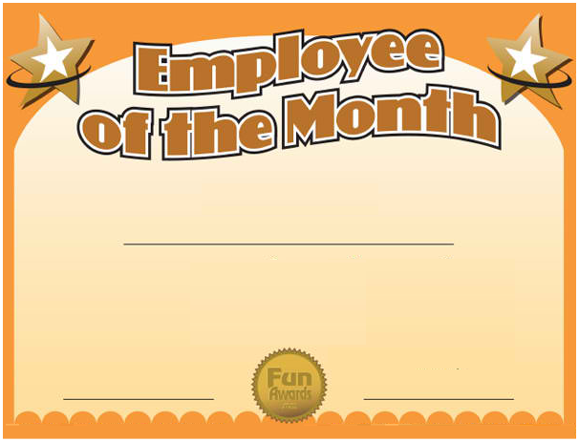

The most dedicated worker for the year ______

Hereby presented to