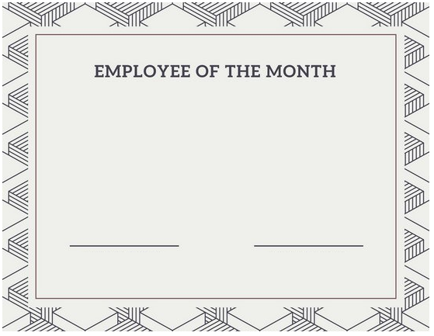

Presented to

Recipient name

In honor of your excellent performance

As January 2014 employee of the month

Signature. CEO […] HRM [….]