


Employee direct deposit authorization
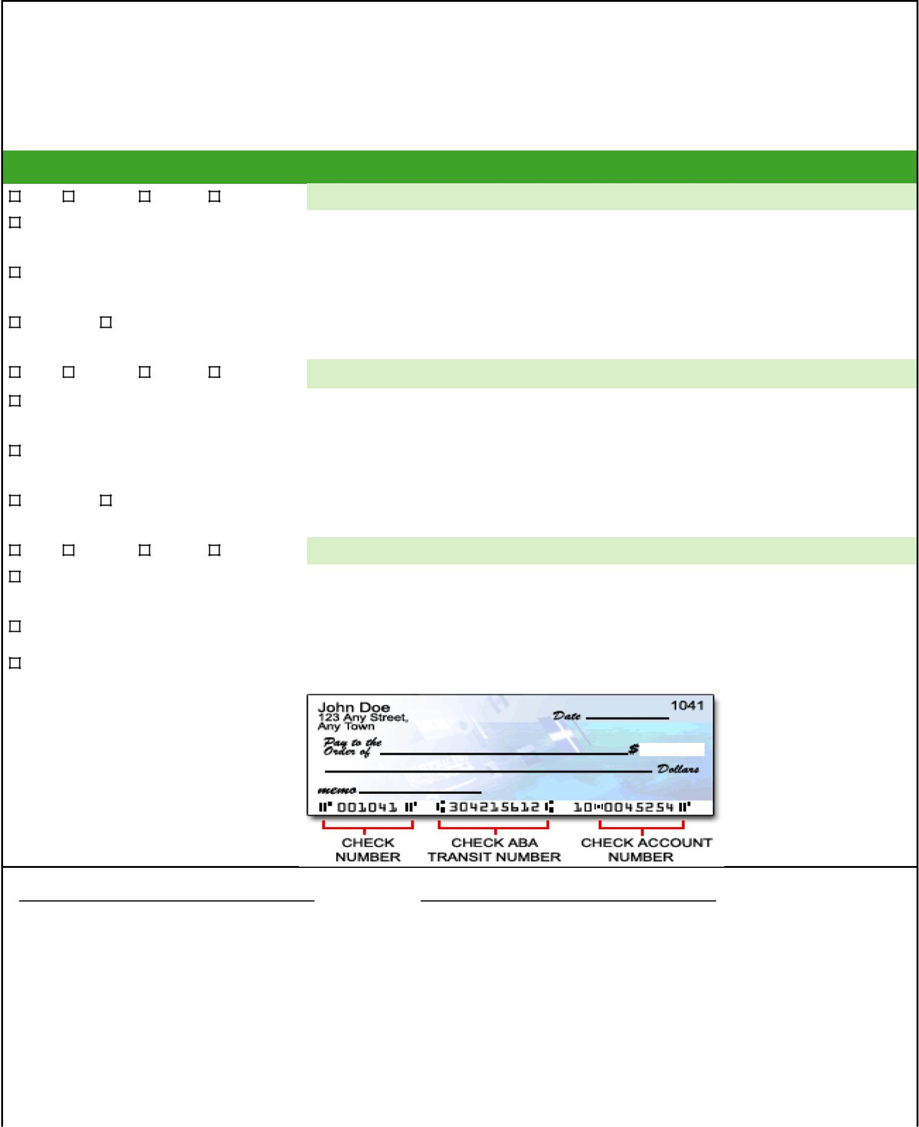
Attention

Employee name |  |  |  |  | Company name | Client name
Requested by |  |  |  |  | Submission date | Client fax
Account type |  |  |  |  | Bank account information
Add | | Change | |  | Delete | | New | Account information: please check account #’s to ensure accuracy
Checking |  |  |  |  | Transit #
Savings |  |  |  |  | Account #
% Amount | |  | $ Amount |  |  | Note amount
Add | | Change | |  | Delete | | New | Account information: please check account #’s to ensure accuracy
Checking |  |  |  |  | Transit #
Savings |  |  |  |  | Account #
% Amount | |  | $ Amount |  |  | Note amount
Add | | Change | |  | Delete | | New | Account information: please check account #’s to ensure accuracy
Checking |  |  |  |  | Transit #
Savings |  |  |  |  | Account #
Net |  |  |  |  | Note: entire net pay balance will be deposited to this account

Please use this as reference for obtaining your correct account information.

Write void across check and attach here or as a separate page

I, hereby authorize ,hereinafter ,called “company”, to initiate credit entries and to initiate, if necessary, debit entries and adjustments for any credit entries in error to my (our) account(s) indicated above and the depository named below, hereinafter called depository, to credit and/or debit the same to such account.This Authority is to remain in full force and effect until company has received written notifi-cation from me of its termination in such time and in such manner as to afford company and depository a reasonable op-portunity to act on it. I also acknowledge that direct deposit is not guaranteed and will take no less than 10 business days from my next check date to begin due to the ACH pre-note test file required.

Signed (Employee) | Date
Signed (Depositor) | Date
Below is reserved for Sage use only.
Date Entered | By

©2015 Sage Software, Inc. All rights reserved. Sage, the Sage logos, and the Sage product and service names mentioned herein are registered trade-marks or trademarks of Sage Software, Inc., or its affiliated entities. All other trademarks are the property of their respective owners. 15-R352 10/15

