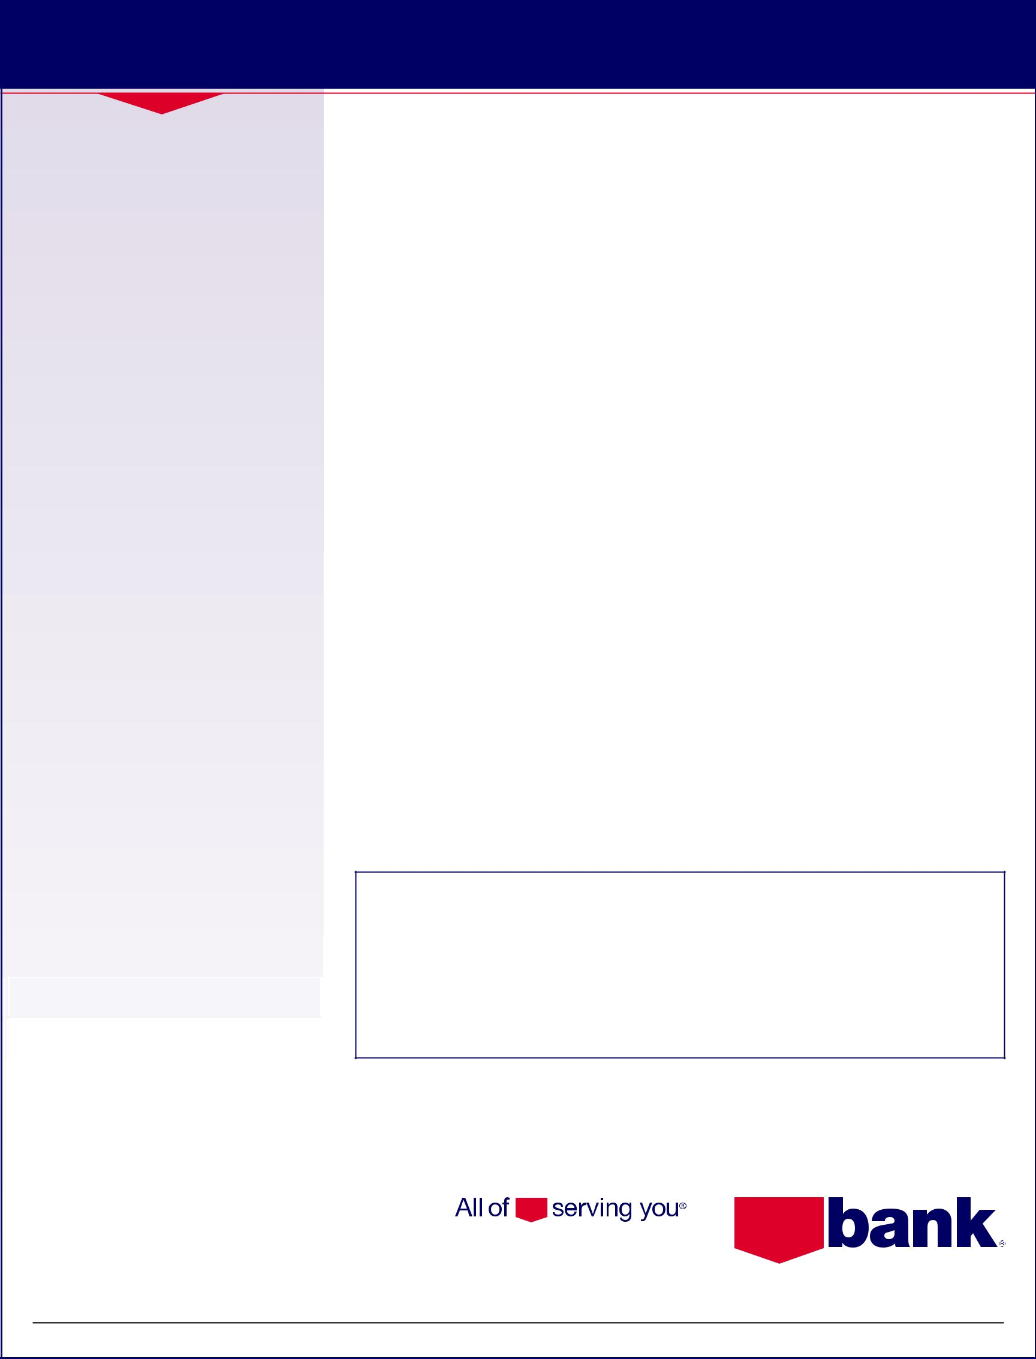
DIRECT DEPOSIT AUTHORIZATION FORM

How to switch your direct deposit(s) to U.S. Bank:

- For payroll checks - Contact your company’s Human Resources department for instructions on updating your direct deposit account information.

- For Social Security checks - Contact your local Social Security Administrative office.

If your company does not have a process in place for updating your direct deposit account information, please follow these steps:

- Complete this form.

- Attach a new U.S. Bank check to the completed form and write “VOID” across the front. Do not sign the check.

- Submit to your employer.

Follow-up on the switch:

- Call your company’s Human Resources department to check on the progress of your request.

- Login to U.S. Bank Internet Banking to verify your direct deposits are being deposited correctly.

Remember, it can take several payroll cycles for changes to take effect!

Thank you for making the switch to US!

usbank.com

To: Payroll Department Subject: Direct Deposit

From: ____________________________________ Date: _____________________

This memo serves as notification that I have established a new checking or savings account with U.S. Bank. Attached you will find a voided check from my new account.

Listed below are the relevant account and routing numbers needed for you to establish payroll Direct Deposit to my new account.

1. U.S. Bank Routing Number: ______________________________________________

(The first set of numbers found on the bottom of your check)

2. U.S. Bank Account Number: ______________________________________________

(The second set of numbers, found after the routing number)

Check One: q Checking Account q Savings Account

Print Name:______________________________________________________________

Employee Social Security Number: __________________________________________

If this form is not sufficient to authorize and complete the direct deposit update, please forward the authorized form for my signature.

Signature: ________________________________ Date:______________________

Phone Number:______________________________

If you have questions, please contact:__________________________________________ at

U.S. Bank Branch Information: ______________________________________________________

Branch Phone Number: ________________________________________________________

Branch Fax Number: ______________________________________________________________

Member FDIC

