Family Tree

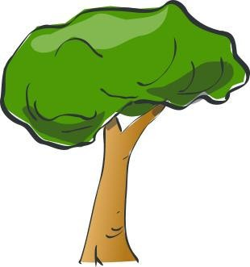
grandfather
grandfather

grandmother
grandmother

mother father

