**Family Tree Template**

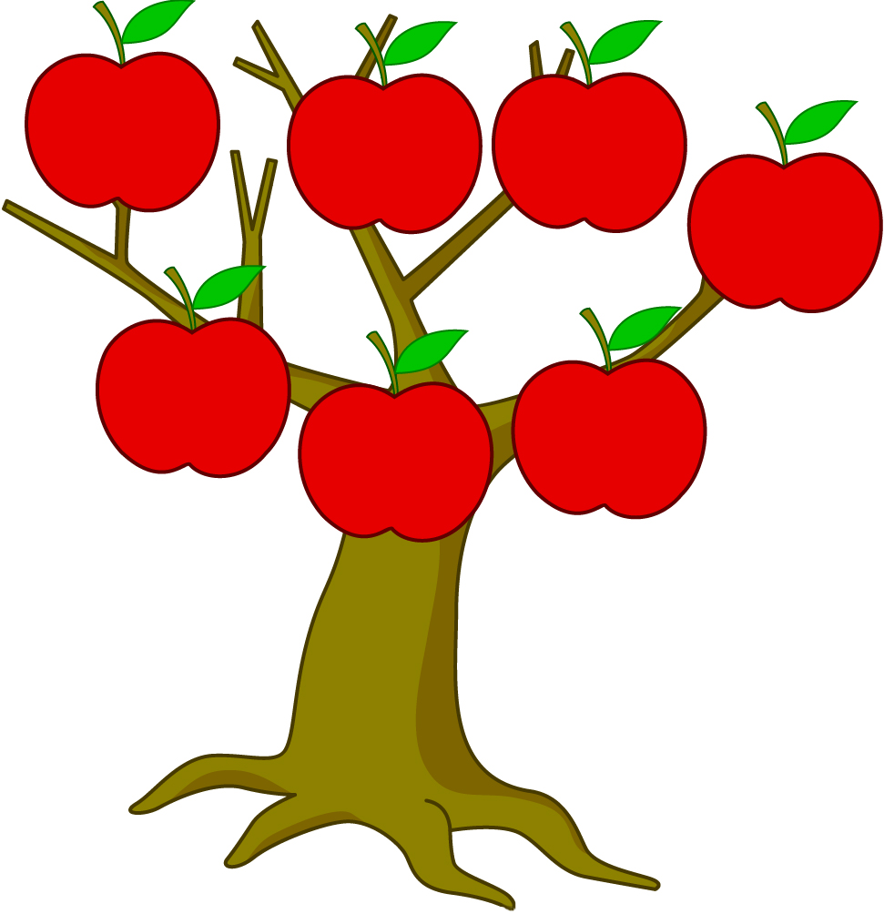

**MY FATHER**

**_______________**

**MY MOTHER**

**_______________**

**ME**

**_______________**

**MY GRANDFATHER**

**_______________**

**MY GRANDMOTHER**

**_______________**

**MY GRANDMOTHER**

**_______________**

**MY GRANDFATHER**

**_______________**