The Tooth Fairy
Tooth Fairy Land

Oh My!

I can’t believe this is your last tooth! It has been so nice picking up every specimen you’ve put under your pillow over the last six years. You always have lovely, clean teeth. They’re so shiny and bright that I made sure to put them all in the east tower of my castle. They really catch the light.

It’s an important time for you now. You have all permanent teeth now, which means that you’ll have them for the rest of your life. It’s therefore vital that you take extra good care to brush and floss every day. Make sure that you eat healthy snacks and avoid junk food.

It has been such a pleasure to be your Tooth Fairy and to get all 20 of your baby teeth. They are so special to me and I hope you’re proud to show off that big, grownup smile!

Love,
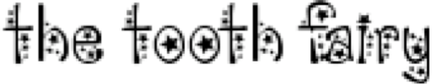
The Tooth Fairy

