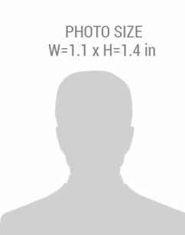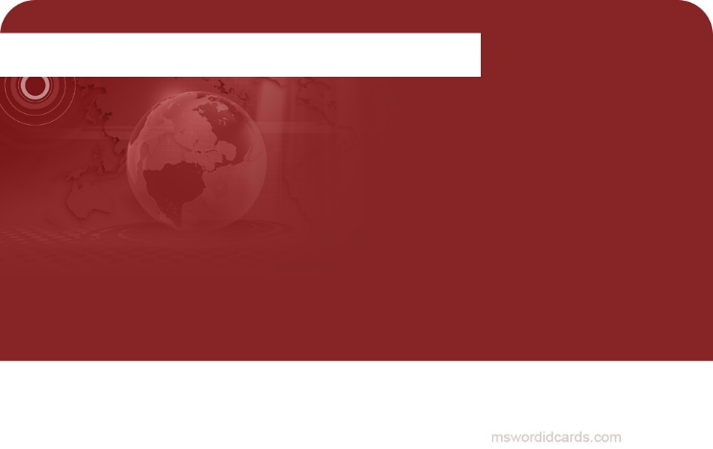barcode.png

+1 241-654-7890

*NEWS MEDIA*

EXPIRY DATE:

DATE OF BIRTH:

PHONE NO:

01-08-1985

December 2018

**NATIONAL PRESS ASSOCIATION**

Press Reporter

DESIGNATION:

***FIRST,*** *LAST NAME*