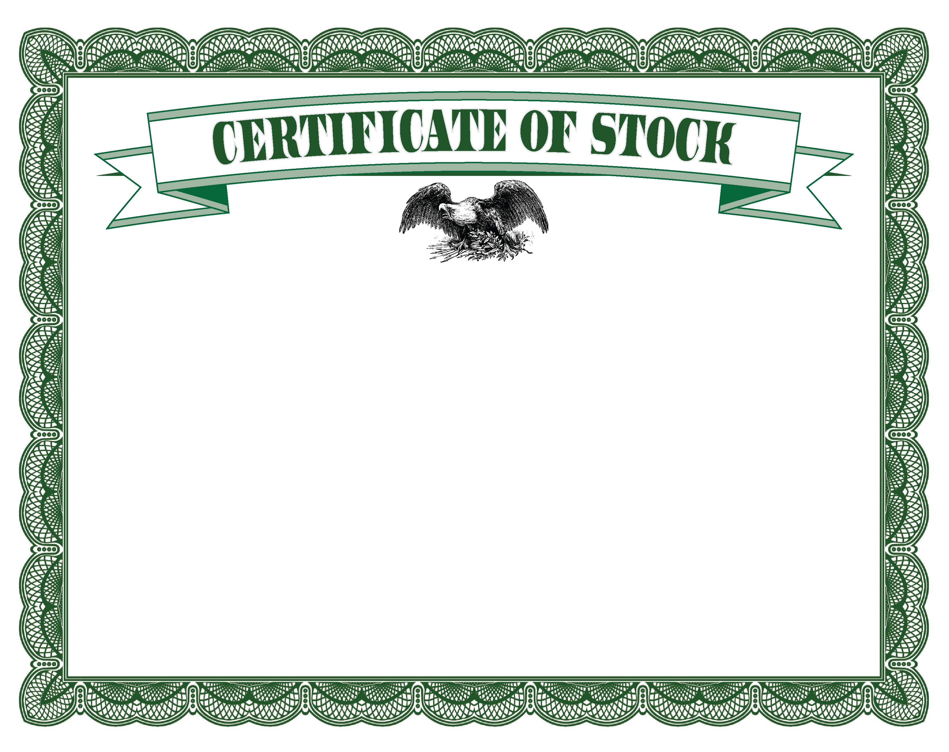

<Signature 2>

<Title>

<Signature 1>

<Title>

This certifies that**<ENTER NAME>** *is entitled to* **<# of Shares>** *shares of the par value of*

**<VALUE OF EACH SHARE>** *each of the* **<TYPE OF STOCK>** *of the* **<COMPANY NAME>***, transferable in person or by Attorney only in the books of the Company and upon the surrender of this Certificate. In witness whereof the* **<COMPANY NAME>** *has caused this Certificate to be signed by its* **<OFFICER 1>** *and* **<OFFICER 2>** *and its Corporate Seal to be hereto affixed at* **<CITY, STATE>**  *this* **<ENTER DATE>.**

<CITY, STATE>

<COMPANY NAME>