

BANKING WITH A

FINANCIAL INSTITUTION

What I need to learn to keep my money safe and help it grow

Financial Education Supported by:


Concept Checklist

What will I learn today?

- ] Financial Institutions

- ] Types of Accounts

- ] Choosing a Financial Institution

- ] Checking Account Basics

- ] Using ATMs

- ] Debit & Other Cards

- ] Deposits

- ] Bank Statements

Curriculum compiled by the International Institute with funding from the Office of Refugee Resettlement, Department of Health and Human Services


Reasons to use Financial Institutions
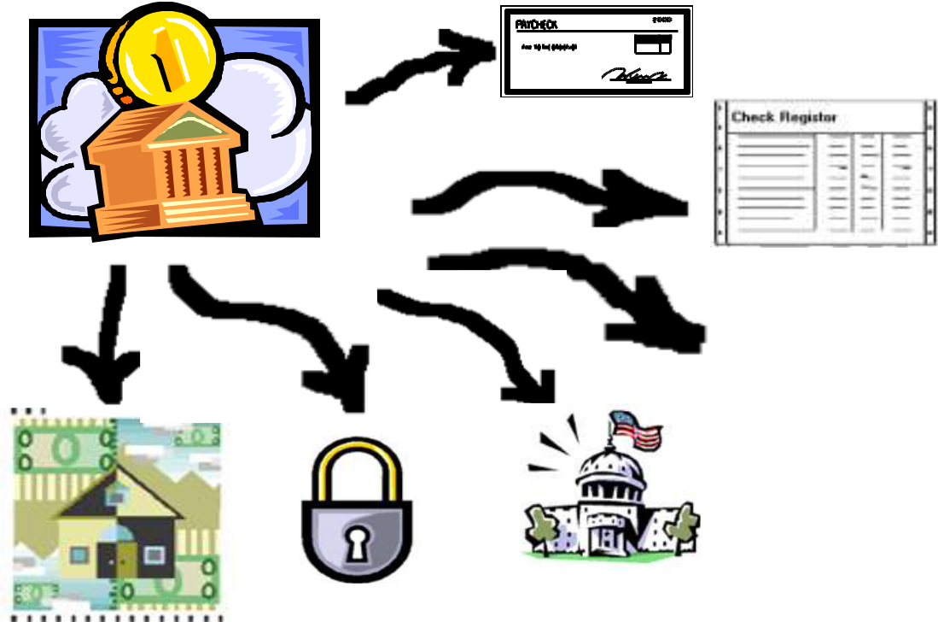

________

_________



_________
______ __________
______

Banks are not your only option!
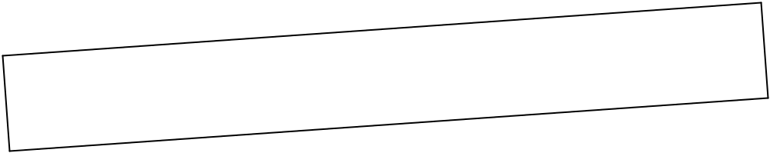

 |  |  |  | n
 |  |  | ns | ca
 |  | nio
 | t U
edi
Cr |  |  |  | g
 |  |  | self bein
 | ine |  | your
Just imag

 |  |  |  |  |  | s.
 |  |  |  |  | ion
 |  |  |  | pt
 |  |  | t o
 |  | ea
o be gr
als |  |  |  |  |  |  | on!
 |  |  |  |  |  | ituti
 |  |  |  |  | ial | inst
 |  |  | nanc
 | wner of a fi
the coo

- When you open an account with a credit union, you become a shareholder

- You can join a credit union by working for a certain company, or working or living in a certain neighborhood.

Specialized financial companies may offer the same services as banks


The best advice is: SHOP AND
COMPARE!



To find out which Credit Unions are available to you, call:
For Missouri: 18004463620
For Illinois: 18009427124 ext. 3299

You: Hello, I am trying to find out what Credit Union I can join in St. Louis. I live at () in St. Louis, Missouri and the zip code is ().

Credit Union Representative: OK, according to your address, here is a list of all credit unions you can join.

You: I also work at () in St. Louis, Missouri (ZIP code) and my company’s name is ().

Credit Union Representative: That will make you able to join even more credit unions, here is an additional list.

What can you do with your Money in a Financial Institution?

- Checking Accounts

- Savings Accounts

- Time Deposits/Certificates of Deposit (CD’s)

- Money Market Accounts

- Investment Accounts

- Safe Deposit Boxes

Type s of Accounts

Type of | Will I | May I | Withdrawal
Type of | earn | write | Withdrawal | Insured?
account | earn | write | limitations? | Insured?
 | interest? checks?
Regular | No | Yes | No | Yes
Checking
Interest | Yes | Yes | No | Yes
Checking
 | Yes, more
Savings | than | No | Yes | Yes
Savings | interest | No | Yes | Yes
 | checking
Money Market | Yes, more | Yes, but | Yes, more | Yes
Deposit(MMDA) | than | limited | than savings | Yes
Deposit(MMDA) | Savings | limited | than savings
Time Deposit | Yes, more | No | Yes, more | Yes
(CD) | than | No | than MMDA | Yes
(CD) | MMDA's |  | than MMDA


Is your Money Insured?

- The United States government protects the money you deposit with banks and credit unions.

- If anything goes wrong with the bank or credit union, the government will give you back your deposited money (up to $100,000).

- Do not use the services of a financial institution that are not INSURED by the government.

Look for these signs on | Look for these signs on the
the documents of the | documents of the credit
bank: | union:



Are Investment Accounts
Insured too?

- Not considered a deposit account.

- Not government insured.

- Not insured by the financial institution.

- You could lose the money.

Simple Interest?
Compound Interest? Annual
Percentage Yield?

How much interest you earn depends on:

– What your interest rate is

– Whether it is simple or compound interest

– How long you keep the money with the financial institution

Simple & Compound Interest

For a deposit of $10,000 for one year:

 | Simple Interest |  | Interest Compounded Monthly
 | Interest Rate of 5% |  |  | Interest Rate of 5%
 | $10,000 x 5% = $500 |  | $10,083.50 x 5% / 12 =
 |  |  |  |  |  |  |  | $42.01
 |  |  | $10,041.66 x 5% / 12 = |  |  | $41.84
 |  |  | $10,000 x 5% / 12 = |  | $41.66
Year End Balance = $10,500 |  |  | Year End Balance = $10,506
Interest Rate: 5% |  |  |  | Interest Rate: 5%
 | APY: 5% |  |  | APY: 5.06%
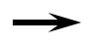

Which Account is best for me?

It depends upon:

– How much risk you are willing to take.

– How much income you expect to earn from your money.

– How often you need to make withdrawals.

There are many different Financial

Institutions. Where should I go?

Shop around Know what to ask Know what you need

Your First Visit to a Bank

You:

Hello. I am interested in opening an account with your bank.

Banker:

Checking or savings account?

You:

I would like to know about all accounts you offer to see which one is best for me.

Banker:

OK, we have checking, savings, money market and CD accounts.

You:

How about interest checking accounts?

Banker:

Yes, we have those accounts too.

You:

Are they all insured by the government?

Banker:

Yes, they are.

You:

Can you tell me how much the minimum deposit is to open each account?

Banker:

You:

Are there any fees for having any of the accounts?

Banker:

You:

What is the minimum balance for each account to avoid fees?

Banker:

You:

What other services can I get as an accountholder, and are they free?

Banker:

You:

Can I make direct deposits to all of these accounts? Is there a fee for this?

Banker:

You:

Can I use the phone and Internet to do banking transactions?

Are there fees for these services?



You: How about ATM machines? Do you have them for all the

accounts?

Banker: Yes, we do.

You: Do I have to pay for the service?

Banker: No, it is free when you use our ATMs.

You: Do you have safe deposit boxes? Are they free for

accountholders?

Banker: Yes, we do and yes, they are!

You: What other free services do accountholders get?

Banker:

You: OK then, I would like to open a checking account.

Banker: OK, will this be a joint account?

You: Yes, I would like my spouse to be able to use the account.

Banker: All you have to do is to fill out this application.

********

Banker: How much are you depositing today?

You: I will deposit more than the minimum required balance to avoid

any fees.

Banker: That is fine. Fill out this deposit slip please, and I will open your

account. Here are your temporary checks. Use these until you

get your permanent checks in the mail.

You: Great.

Banker: Is there anything else I can do for you?

You: No, thank you.


Checklist for Choosing a Bank

Type of Account | Minimum | Minimum | APY | Federally | Other Fees or
Available | Deposit | Balance |  | Insured? | Charges
 | to Open | to
 |  | Maintain
__ Checking
__ Interest Checking
__ Savings
__ Money Market
__ CD

Other Services

__ ATM | ___ Free | __ Fee | How much? $ ___
__ OnLine or Internet | ___ Free | __ Fee | How much? $ ___
Banking
__ Bank by Mail | ___ Free | __ Fee | How much? $ ___
__ Direct Deposit | ___ Free | __ Fee | How much? $ ___
__ Bank by Phone | ___ Free | __ Fee | How much? $ ___
__ Safe Deposit Boxes | ___ Free | __ Fee | How much? $ ___

Ask the Bank for their Fee Disclosures


Information you will need to open an Account with a Financial Institution


- My Full Name
- My Mother’s Maiden Name
- My Social Security Number
- My Birthplace
- My Date of Birth
- My Full Home Address
- My Full Work Address
- My Daytime and Evening Phone Numbers

If I apply For a joint account (in addition to the above):


- My Joint Applicant’s Full Name
- My Joint Applicant’s Mother’s Maiden Name
- My Joint Applicant’s Social Security Number
- My Joint Applicant’s Birthplace
- My Joint Applicant’s Date of Birth
- My Joint Applicant’s Full Home Address
- My Joint Applicant’s Full Work Address
- My Joint Applicant’s Daytime and Evening Phone Numbers

The financial institution will also ask for:

- Signatures of Both My Joint Applicant and Me
- Social Security Cards for Both My Joint Applicant and Me

- Interestearning accounts will require a social security number. Noninterestearning checking accounts can be opened with an I94 document before receiving social security number. (You will receive a tax form at the end of the year reporting how much money you made from interest)
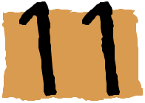
I opened a Bank Account. What are the Financial Institution’s responsibilities?

- Protecting my money and personal information.

- Providing all the services that they have agreed to in their disclosures.

- Providing me with access to my money as described in the disclosures.

I opened a Bank Account.
What are my responsibilities?

- Selecting the type of account that will fit my banking needs.

- Understanding and meeting the requirements (found in disclosures) of the accounts I opened.

- Protecting all my financial information including my check book and ATM card.

- Keeping records of all deposits and withdrawals and comparing them monthly with my bank statements.
How to Withdraw Money from a Checking Account?
- 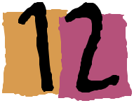Amount of check in numbers
- Your signature

- Go to any branch of the bank where you hold an account (With proper photo ID and account information)

- Write a check. (It is important to learn the safe and correct way to write and endorse checks)

- Use ATM cards. (Make sure nobody sees you enter your PIN number into the machine)

- Use the phone. (Do not use wireless phones)

- Use the Internet from a secure site or source.

Correct way to Write a Check

Check number
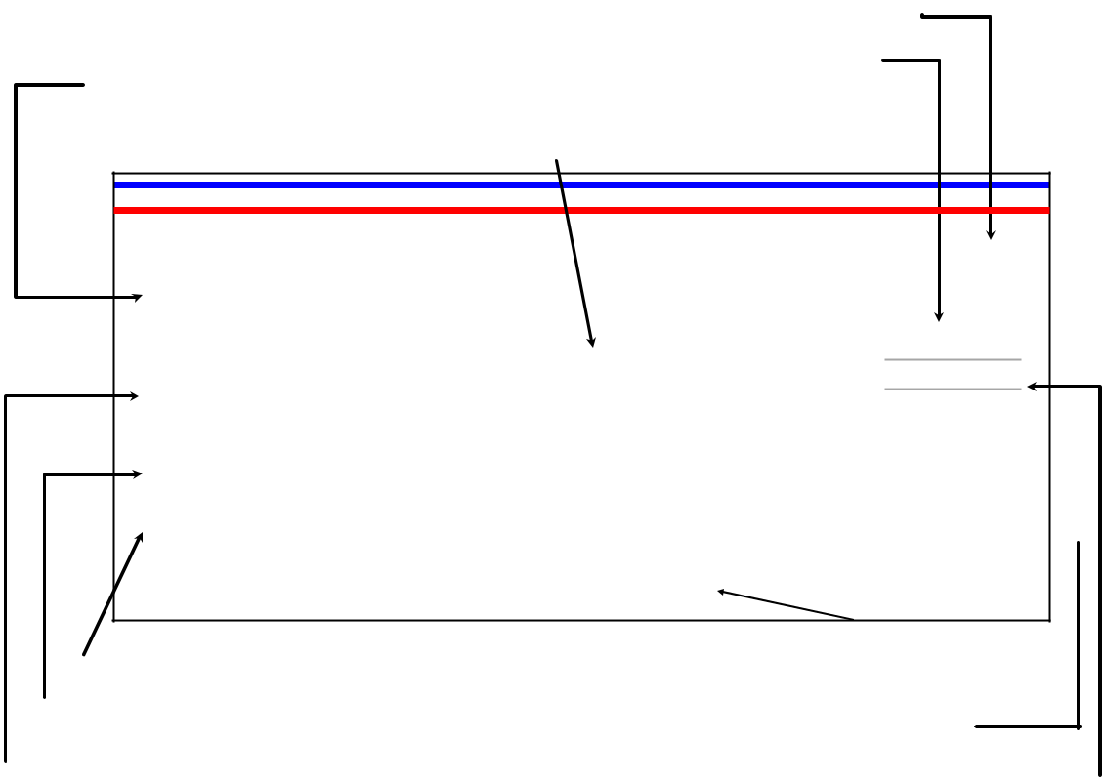

Date you wrote the check
Your name/address

Name of the person/business you are paying

Mrs. Great Customer

101

12345 Any Street.

St. Louis, MO 63118

Date ________________

Pay to the order of _____________________________________________________ $

_______________________________________________________________________ Dollars

The Friendly Bank

56789 Any Ave. St. Louis, MO 63016

For ______________________ ___________________________ 

********246659***78765465454***101********

Bank routing, account number and check number

Use this space to write the purpose of the check

Name of your bank

The amount of check in words

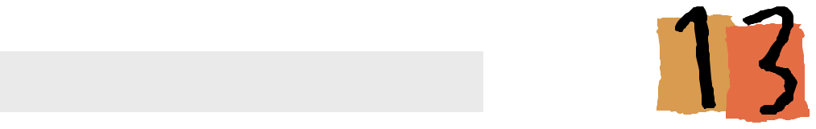
Endorsing a Check

Space for
endorsement &
instructions by
the person who
has the legal | Space for the
right to deposit | Space for the
right to deposit | bank where the
 | check is first
 | deposited
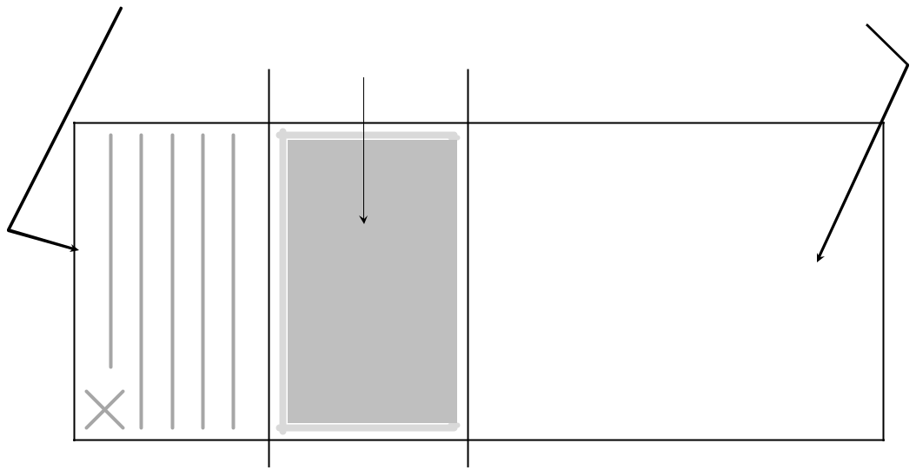

Space that can be used between related banks or to record additional information about the person who made the deposit

DO NOT

WRITE

HERE

What happens to my Check
after I write it? What is Check 21?

 | Notify in |  | Me |  | Mail
 | Notify in |  | The Check Issuer
 | Statement
My |  |  |  |  |  | My Brother
Bank |  |  |  |  |  | The Check Receiver
 |  | The Story of A
Collect | $100 Birthday Gift |  |  |  | Deposit
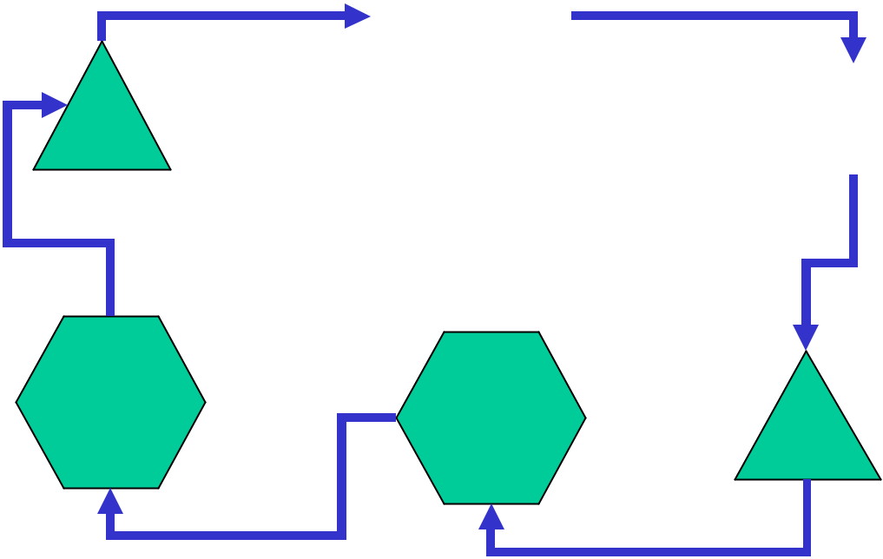

Federal Bank |  | His
In My Region | Federal Bank | His
 | In His Region | Bank
 | Send to | Send to
 | Collect | Send to
 | Collect | Collect

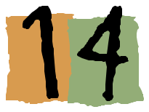
Check Writing Basics:
How to correctly write the date

Always use the current date on a check. Write out the date instead of numbers.

Example:


March 1, 2006

3/1/2006


How to correctly write
the dollar amount

- When writing a check, start as far to the left as possible on each line. Draw a line through any remaining space.

Example:

• one hundred and 25/100 Dollars.

one hundred and 25/100 Dollars.
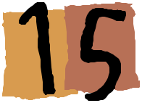
Check Writing Basics:
How to correctly write the payee

- Do not use abbreviations on the “pay to the order of” line. Here is what can happen if you do so:

Example:

Pay to the order of I B M


Pay to the order of I B Morgan


How to correctly write
the amount of the check

- When writing the amount of the check, print do not write in cursive.

Example:

one hundred and 25/100


one hundred and 25/100
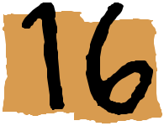
Check Writing Basics:
How to correctly
endorse your check

- Always sign your name in the same way it is on file with the bank.

Example:

If your signature on file is: 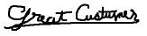 then, do not sign:
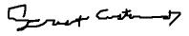


Always use a pen
when writing a check

- Always write with a pen on the check. Do not write with a pencil or any ink that is easy to erase.

Example:

If you write with a pencil,
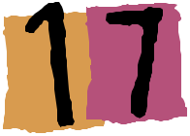
Reasons Banks may not
Accept Your Check

- Not enough money in your account (nonsufficient funds).

(This depends on who you bank with, the type of your account, your credit history and the amount of the check)

- Handwriting and signature do not match the bank’s signature card on file.

- Check is dated wrong.

- No legal endorsement.

- An error when the check was deposited.

- A stoppayment order was issued.

- A hold order on your account.

Other Types of Checks

- Certified Checks

- Cashier’s Checks

- Money Orders

- Travelers Checks
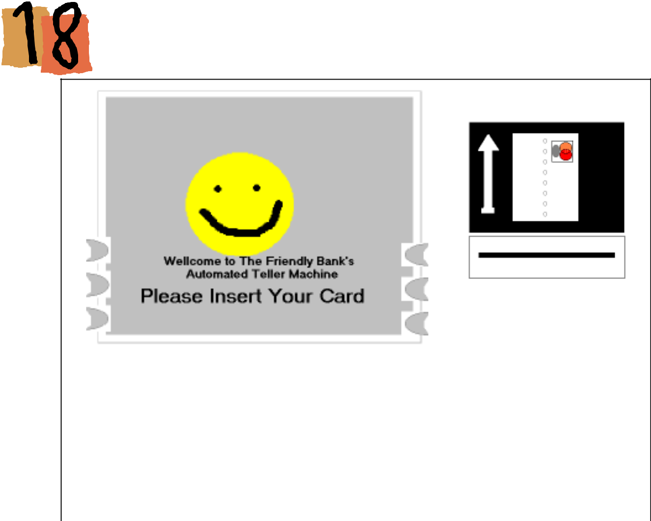

Insert Card Here
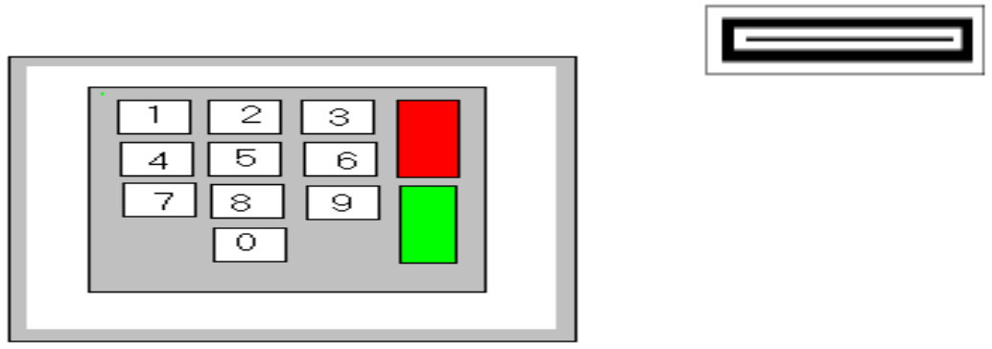

Take Receipt
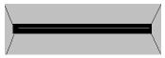

Take Cash Here
!
t
n
a
t
r
o
p
m
I

If you need to learn how to use the ATMM,, please schedule an appointment with an IDA staff person. The IDA staff person will go with you to one of your bank’s ATMM machines to teach you how to use the machine.
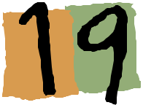
Using ATM cards
Effectively and Safely

- Do not give your Personal Identification Number (PIN) to anyone.

- If anyone is waiting for their turn to use the ATM after you, stand so that the person behind you cannot see what you are doing.

- Save all receipts and record all of your transactions in your check register.

- Report a lost or stolen card immediately by calling the appropriate number at your bank.
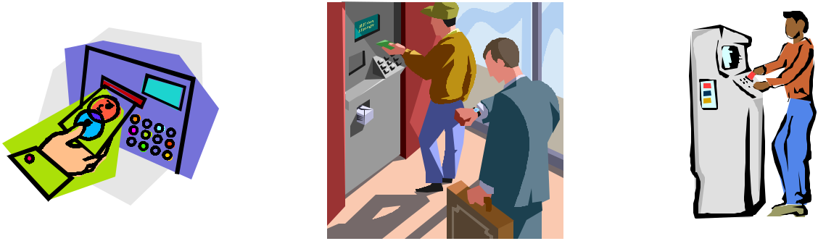

- Be aware of your surroundings when you use an ATM, especially at night. Use ATMs only in welllit areas.

- If you noticed anything unusual, cancel your transaction, put your card back in your pocket, go to a safe place, and call the police if you suspect dangerous or illegal activities.

- Treat your ATM card as cash.

- Do not write down your PIN on your ATM card. Keep it where you put important documents and memorize it.

Debit & Other Cards
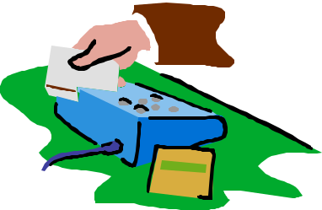
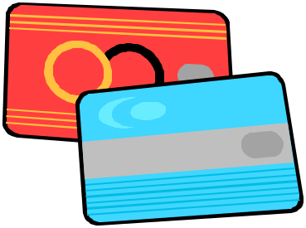

Debit Cards
Phone Cards,
Stored Value Cards &
Smart Cards

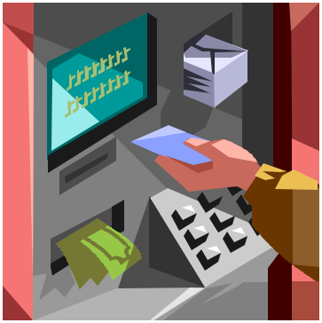

Electronic Benefit
Transfer Cards (EBT)
(Food Stamps)

ATM Cards

It is important to understand and know the differences between each of these cards
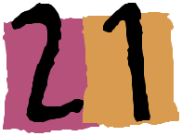

How to Deposit Money
into a Bank Account

– Going to the bank yourself (for cash and checks)

– Do not mail cash

– By direct deposit (for payroll checks)

– Using the ATM (for cash and checks)

– By mail (if you are sending a check or money order)

– By phone (if you are transferring between your accounts)

– On the Internet (if you are transferring between your accounts)


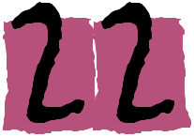
How to correctly complete a Deposit Slip
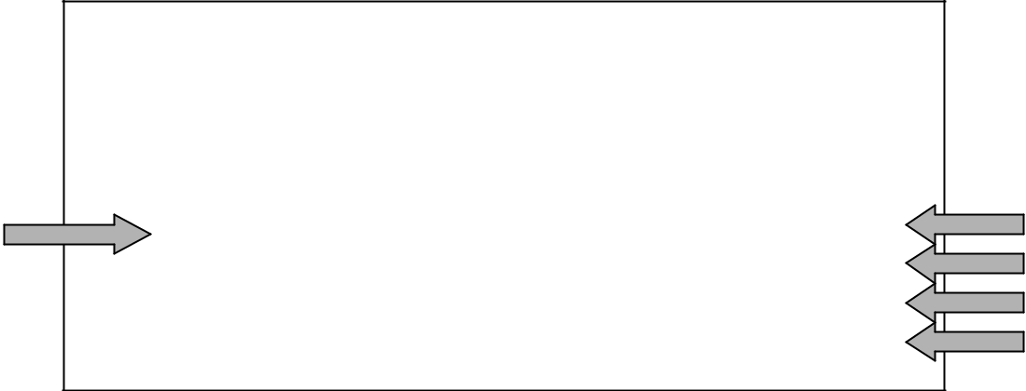

 | Mrs. Great Customer
 | Mrs. Great Customer | CURRENCY
 | 12345 Any Street
 | 12345 Any Street | COIN
 | St. Louis, MO 63118
 | St. Louis, MO 63118 | C
 |  | H
 |  | E
 | Date__________________________ | C
 | Date__________________________ | K
 |  | S
 |  | TOTAL FROM
1 | __________________________ | OTHERSIDE
1 | Signature | SUBTOTAL
 |  | LESS CASH
 |  | TOTAL DEPOSIT
******* 246659****78765465454********

- Your signature is required for you to receive cash from your deposit.

- If you have several checks to deposit, you need to list them all on the back of the deposit slip and write their total in this space.

- The total of your deposit before any cash back.

- The amount of cash you want to take out of your deposit.

- The total of your final deposit.

2
3
4
5

 | Back of the deposit slip
 | CHECK No. | AMOUNT
The check
numbers of
each check
to be
deposited
This amount | TOTAL
must be shown | TOTAL
in the total
deposit field
on the front of
the deposit slip
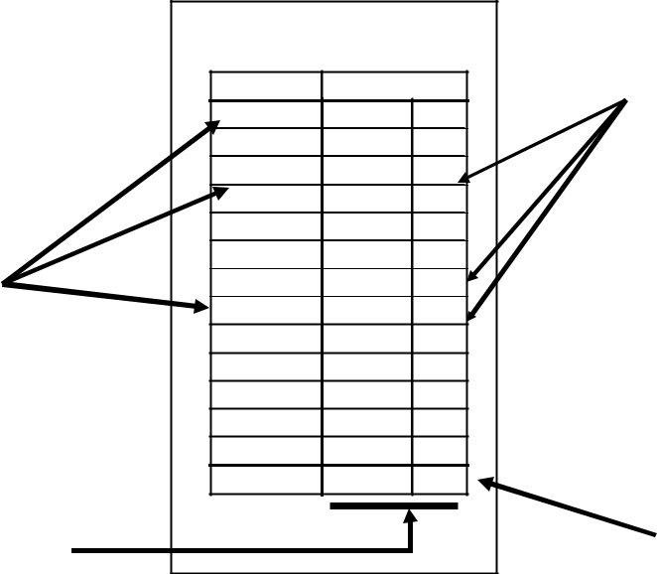

The amount
of each check
to be
deposited

Total amount
deposited by
checks

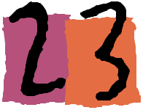

Making a Deposit

You:

Banker:

You:

Banker:

You:

Banker:

You:

Banker:

You:

Banker:

You:

Good Morning.

Good Morning. What can I do for you today?

I want to deposit this check into my checking and

savings accounts. I would like to deposit $100 into my

savings account and the rest into my checking account.

Do you have your account numbers?

Yes, I do. My checking account number is () and my

saving account number is ().

OK, I need you to fill out this deposit slip as if you are

depositing the entire amount into the checking

account, taking out $100 cash and then fill out the

other deposit slip as if you are depositing that $100

dollars again, but this time into your savings account.

I think I understood what you said, but I need you to

help me with it please.

Certainly. And I need to see a photo ID, either your

drivers license or state ID please.

Of course, here you are.

Thank you.

You’re welcome.

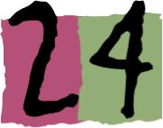 Keeping Records, Keeping Safe!

- Always check your bank statement against your receipts and check register. Occasionally banks do make mistakes.

- It is your money, so take the time to make sure your bank transactions are correct. Learn to record your transactions and always compare them with your bank statements.

- You will find out that it is something you can easily do with all of your other monetary transactions as well.

- It is a great tool to monitor and better control your money.

Overdrawn? Insufficient Funds?

Checking Account Register

The place to write any fees
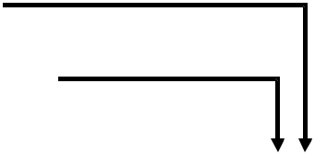
charged for the transaction

You can put a mark if the
transaction is a tax deductible
item

 |  |  | PAYMENT/ |  |  |  | DEPOSIT/
CHECK |  | TRANSACTION | DEBIT () |  | √ | () | CREDIT (+) |  | BALANCE
CHECK | DATE | TRANSACTION | AMOUNT OF |  | T | FEE | AMOUNT OF
NUMBER |  | DESCRIPTION | PAYMENT OR |  |  |  | DEPOSIT OR
NUMBER |  | DESCRIPTION | WITHDRAWAL () |  |  |  | INTEREST (+)

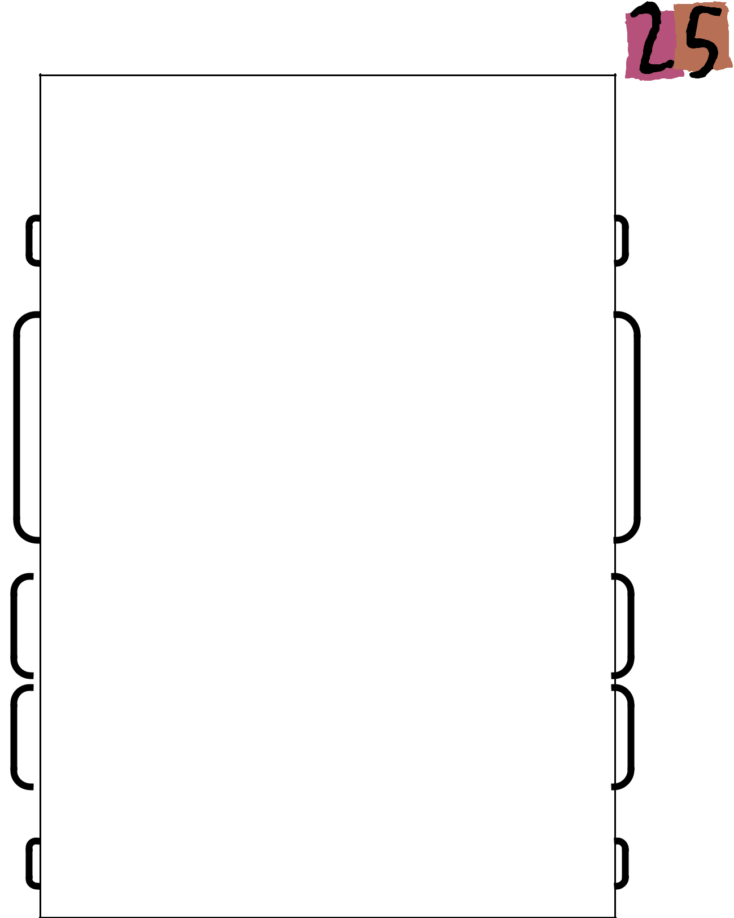
Reading your Bank Statement

THE FRIENDLY BANK |  | CHECKING ACCOUNT STATEMENT
ACCOUNT NUMBER: 78765465454 |  | ACCOUNT CODE: 96E
 | MRS. GREAT CUSTOMER
 | 12345 ANY STREET
 | ST. LOUIS, MO 63118
STATEMENT DATE
10/01/2006
BEGINNING BALANCE | +DEPOSIT/CREDIT | WITHDRAWALS/CHARGES | =NEW/ENDING BALANCE
145.52 | 140.83 | 165.59 | 120.76

CHECKS | AMOUNT | DATE
8452 | 9.86 | 09/06
8453 | 24.50 | 09/15
8455* | 5.00 | 09/23
8456 | 13.75 | 09/28

*Indicates Break in sequence

- OTHER DEBIT/WITHDRAWALS

 | AMOUNT | DATE
TRANSFERS TO SAVINGS | 20.00 | 09/15
ATM WITHDRAWAL | 40.00 | 09/19
AUTOMATIC LOAN PAYMENT | 47.56 | 09/30
SERVICE CHARGE | 4.90 | 10/01
CREDIT/DEPOSIT
CUSTOMER DEPOSIT | 66.95 | 09/08
CUSTOMER DEPOSIT | 63.88 | 09/22
CUSTOMER DEPOSIT | 10.00 | 09/29

DAILY BALANCE SUMMARY

09/06 | 135.64 | 09/22 | 181.97 | 09/30 | 125.66
09/08 | 202.59 | 09/23 | 176.97 | 10/01 | 120.76
09/15 | 158.09 | 09/28 | 163.22
09/19 | 118.09 | 09/29 | 173.22

If you have a question or concern regarding your account, please call us at 1800FRIENDLY, or contact any of our local banking centers.

- The account SUMMARY

- Detailed SUMMARY of all checks and other withdrawals III. Detailed SUMMARY of deposits and other credits
IV. SUMMARY of daily balances of the account
- Information about how to reach customer service

I

II

III

IV

V
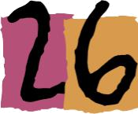
Direct Deposit, Savings Bonds & Remittances
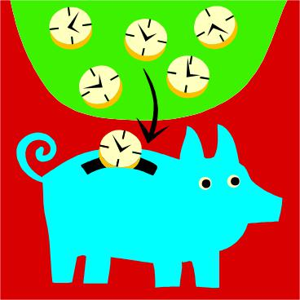

Direct Deposit
- You can make regular electronic “direct deposits” of your paycheck into your bank account
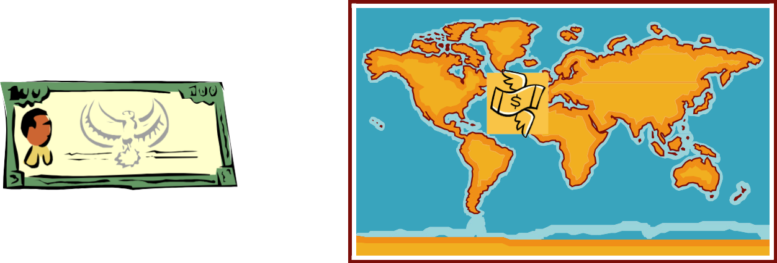

Savings Bonds  Remittances

Do you ever send money home?
This is called a remittance

Ways to send cash include:
•Wire Transfer
•ATM Network
•MoneyGram
•Western Union
•American Express

•U.S. Postal Service (U.S. only)
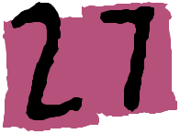
Glossary

Account Balance
The total amount of money in an account at a certain time.

Annual Percentage Yield (APY)

The percentage of compound interest you earn on the money you deposit with a financial institution. The financial institution is required by law to inform you about the APY before opening an account.

Bank Statement

A statement sent on a regular basis by the financial institution where you hold your accounts,to keep you informed of all banking transactions you made with your accounts within a certain period of time.

Cash

The most excepted way of exchange. It is money issued by governments in form of coins and paper (like Dollars and Cents).

Certificate of Deposit

A type of account where you deposit money for a certain amount of time when you know you will not need it during that time. You cannot remove the money before the time ends or you will pay a penalty. This type of account should be insured and it earns more interest than a regular savings or money market account.

Check

A form of written order we use to tell our bank or financial institution to pay money or transfer funds from our account to the checkholder.

Checkbook

A book that is made from detachable checks and deposit slips along with a table to record deposits and withdrawals for a checking account.

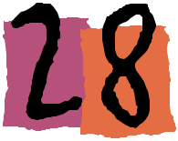

Checking Account

A type of account where you deposit money to have it available for you whenever you want it. With this type of account, you will be able to write checks and usually will not earn any interest, unless it is a special type of checking account. This type of account should be insured by the government.

Compounding

Earning interest on interest.

Confidentiality

The way information is kept hidden from people who do not have the right to know about it.

Earned Interest

The payment a person receives for allowing a financial institution or corporation to use his/her money.

Fee

An amount of money you are required to pay to get a certain service or when you do not meet the terms of your agreement. Financial institutions are asked to inform you about all possible fees and charges that you might have when you open an account. This can be different from one financial institution to another. This information is found in the disclosures.

Financial Institution

A business that accepts money and lends it or invests it.

Initial Deposit Required

The smallest amount of money a financial institution would ask you to deposit to be able to open a certain account. This amount can be different from one financial institution to another.

Interest

Payment for the use of money.
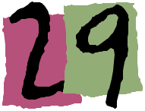

Minimum Balance Required

The smallest amount of money a financial institution would ask you to keep in your account always to avoid fees or service charges. This amount can be different from one financial institution to another.

Money

Anything that has value and is accepted in the exchange of goods and services between people.

Money Market Account

A type of account where you deposit money and the financial institution will take all the risk of investing it. You will be able to write limited checks and will earn interest that is higher than a regular savings account. This type of account should insured by the government.

Safe Deposit Box

A service provided by some financial institutions where you can put your valuable jewelry, documents or anything of value you want to protect in a safe box with the financial institution. No one will be able to open the box but you. You may be expected to pay for this service in some financial institutions.

Saving
Money set aside for short an/or longterm goals.

Savings Account

A type of account where you deposit money you know you will not need for everyday expenses. With this type of account you will usually not be able to write checks, but you can earn interest. This type of account should be insured by the government.

Notes:

__________________________________

__________________________________

__________________________________

__________________________________

__________________________________

__________________________________

__________________________________

__________________________________

__________________________________

__________________________________

__________________________________

__________________________________

__________________________________

__________________________________

__________________________________

__________________________________

__________________________________

__________________________________

__________________________________

__________________________________

__________________________________

__________________________________

